# Major research part:1 Appendix

## Appendix 1: Survey Questions

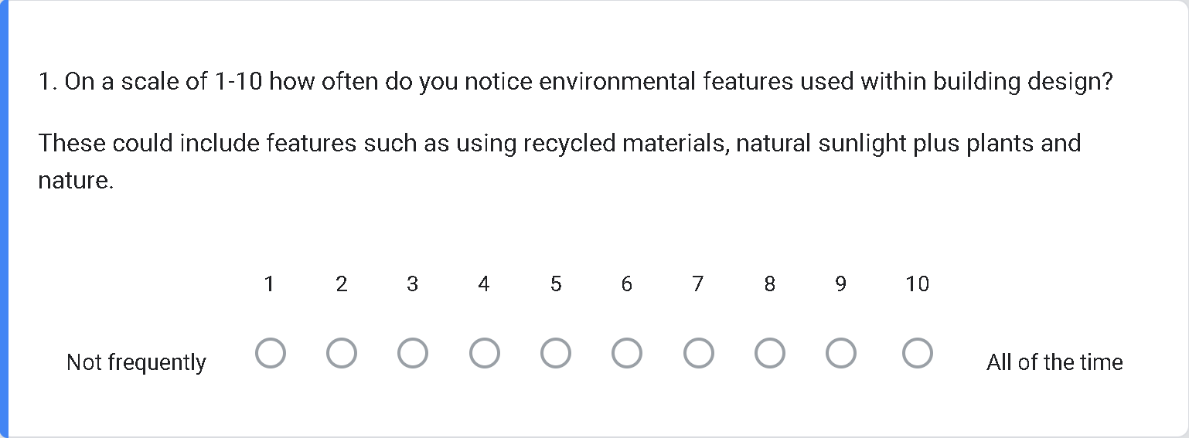

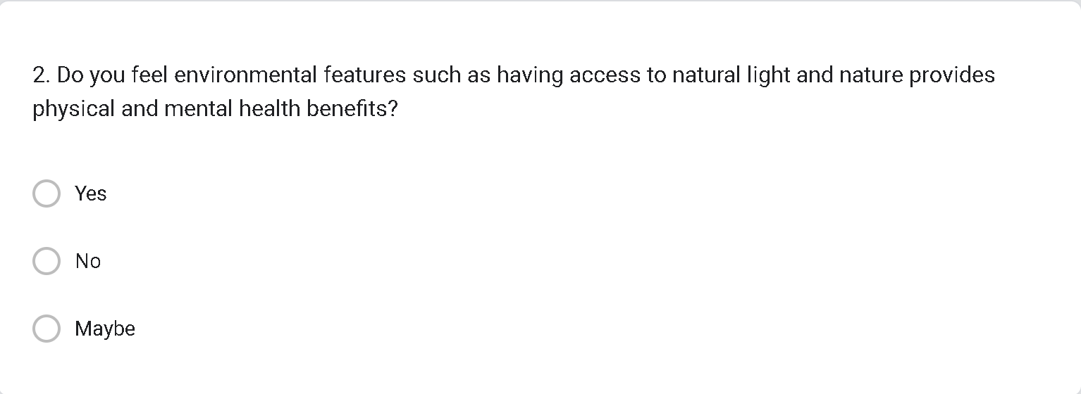  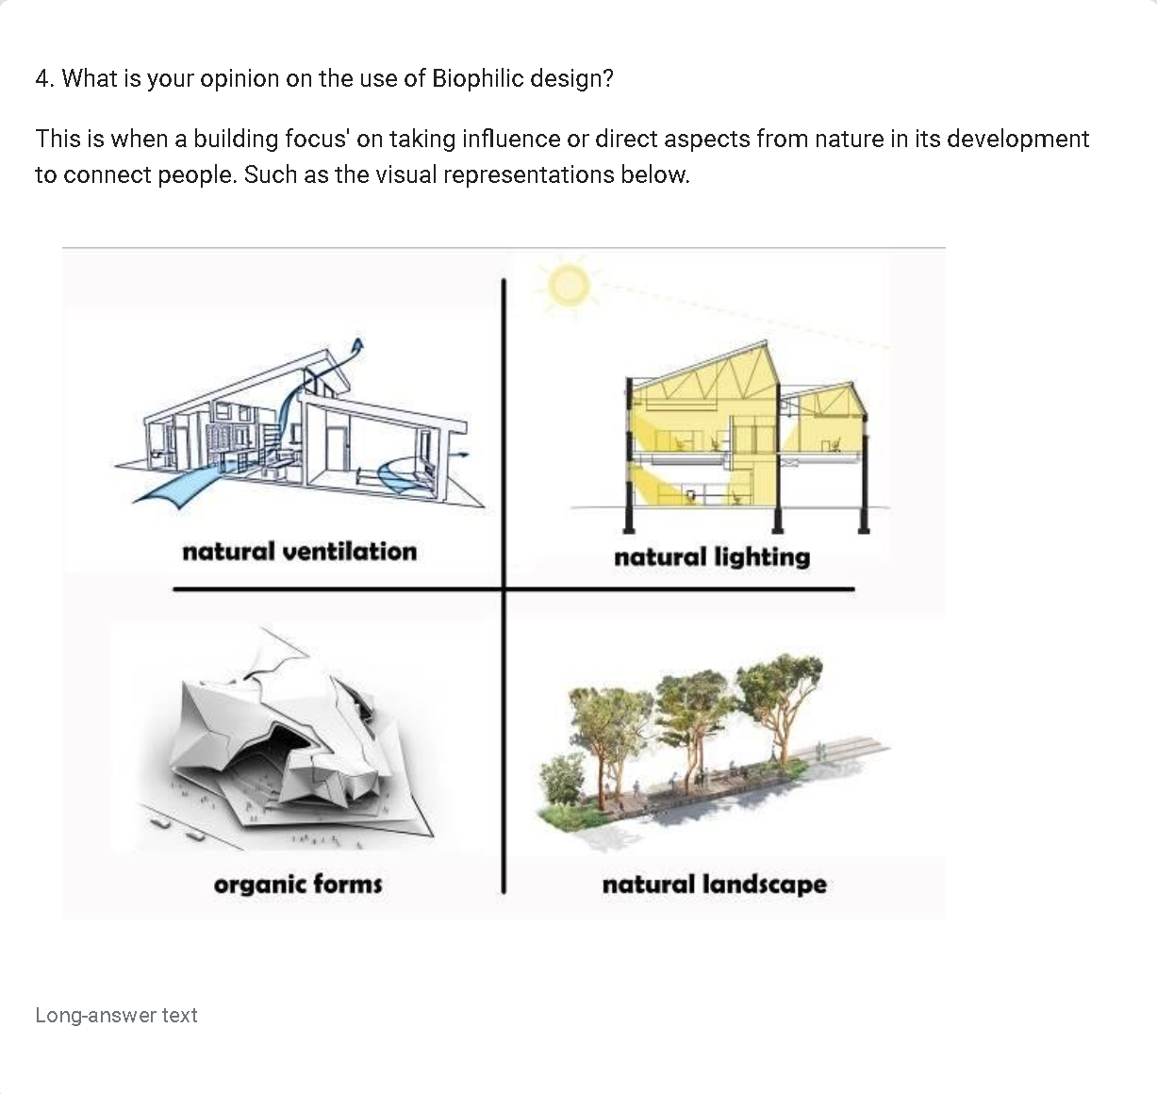 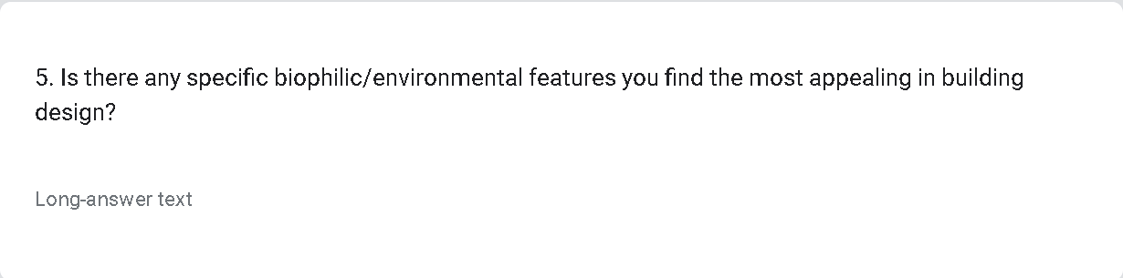 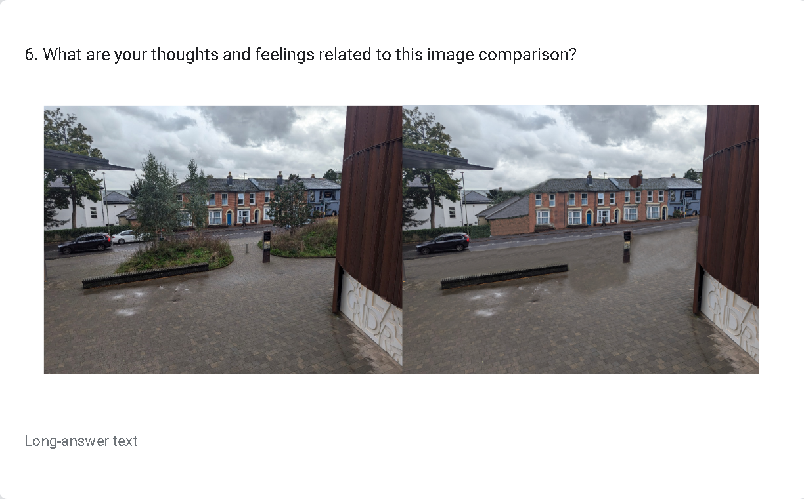 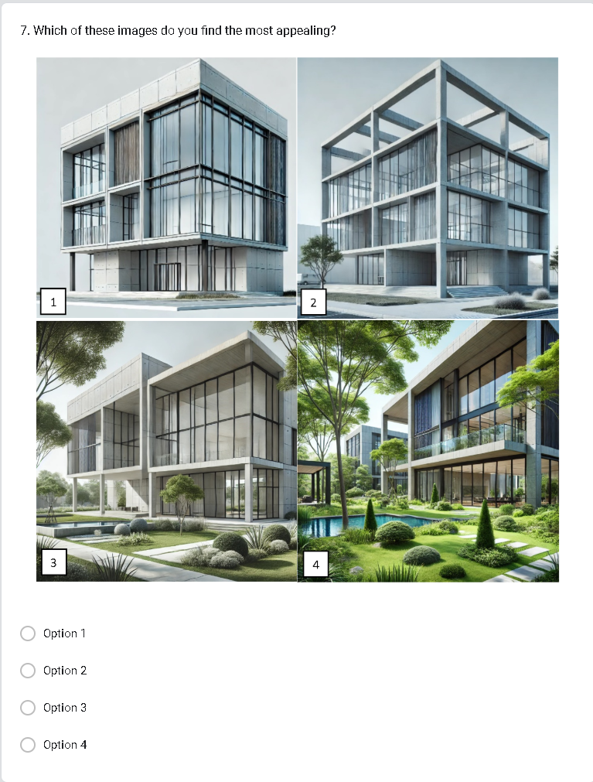 

## Appendix 2: Expected survey results

|  |  |  |
| --- | --- | --- |
| Question | Relevance | Expected Answer |
| • 1. On a scale of 1-10 how often do you notice environmental features used within building design? | It helps me understand if environmental features are used frequently and or noticed by individuals. | 4 |
| * 2. Do you feel environmental features such as having access to natural light provides physical and mental health benefits | This question showcases does the individual feel the benefits proposed by environmental features | Yes |
| * 3. Do you think environmental design enhances the appearance of a building? | This question asks the individual do they believe environmental design improves the aesthetic of architecture showcasing do people believe it to be an improvement or not, answering if it is important to consider environmental features in architecture. | Yes |
| * 4. What is your opinion on the use of Biophilic design?   This is when a building focus' on taking influence or direct aspects from nature in its development to connect people. | It helps me to try explain what biophilic design is to the individual and also provides their opinion on its use. | I don’t normal recognize it but I do believe it improves the appearance of architecture. |
| * 5. Is there any specific biophilic/environmental features you find the most appealing in building design? | This specifies what environmental features people prefer and therefore I should include in my project. | N/A |
| * 6. What are your thoughts and feelings related to this image comparison? | Provides a real life side by side comparison of an area with and without environmental features to clearly show the point I am trying to make across. | That the image with environmental features is an improvement |
| * 7. Which of these images do you find the most appealing? | These images showcase the range of environmental features that can be used and showcases to me the preferred amount of features | 3 or 4 |
| * 8. Could you provide reasoning for your response on question 7? | This gives me more information on the individuals opinions and allows me to understand their thoughts to be applied to my research. | N/A |

## Appendix 3: Survey results

Question 1:

Forms response chart. Question title: 1. On a scale of 1-10 how often do you notice environmental features used within building design?

These could include features such as using recycled materials, natural sunlight plus plants and nature.. Number of responses: 56 responses.

Question 2:

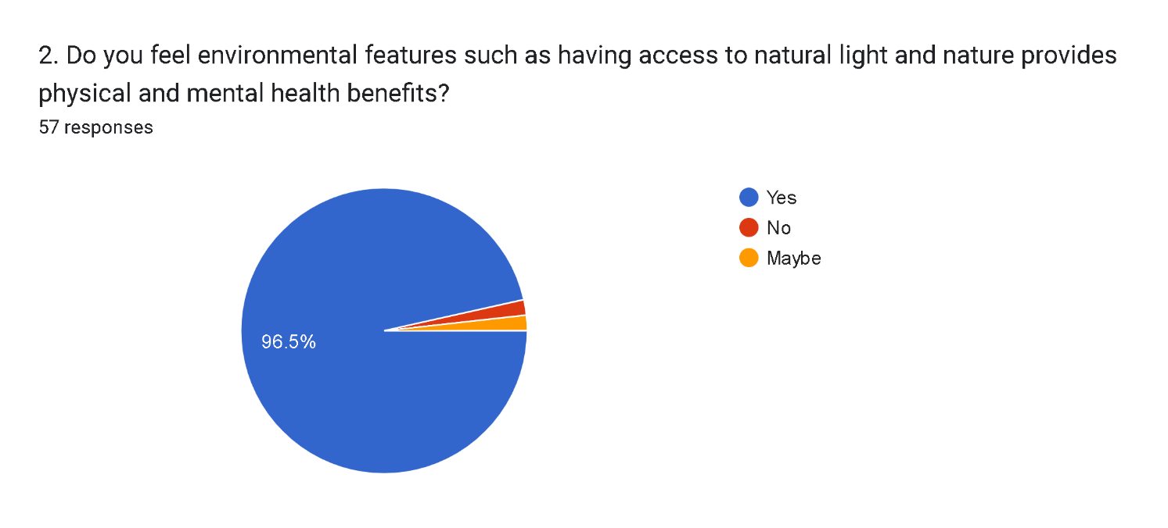

Question 3:

1. Yes
2. Depends on the building and the purpose
3. Yes, definitely, being in an environment with lots of natural light lifts the spirits and natural features give a feeling of being close to nature.
4. I think it does the power of green as a colour can effect our human mood and the interaction with the built environment. it would be interesting to note if this was purley down to colour or it is a combination of colour and shape? the leaves and forms of green or living walls ect whilst enhancing the environment for wildlife perhaps gives us more joy because fo shape and form. Brutalist architecture can be beautiful, the way that light is cast and shadow comes into play, movement of light seems to be a quality that we do not consider highly enough.
5. Absolutely, especially natural sunlight ventilation and plants make a huge difference in mental health and air quality.
6. Yes I belive now more than in recent years building designers have been taking into consideration of nature and how it can be intertwined with the projects and how it’s that can be put good use
7. Strongly agree
8. yes, I would much rather look at a city filled with nature inspired design than loads of monotone, basic buildings
9. Yes, it gives a more pleasant appeal when things are more natural and less industrial feeling. They create a more positive and light environment.
10. Definitely. I wouldn't teach and research neuroenviromental design, the biophilia effect, and biophilia design if I didn't. rob@cwe.solutions if you want to make contact.
11. I think when done in the right way it can elevate the building and really make it look beautiful, but if these features are shoe horned into the design it can look tacky, almost like it's trying to hard
12. Yes it would.
13. yes
14. I think it can make a building look less out of place
15. Makes it more comfortable and open
16. Yea sure! Why not
17. yes, it makes it look nicer
18. Yes, makes the place feel more inviting as well as makes the building more attractive. The scenery can also boost moral and have a calming effect
19. Absolutely. My only counter argument would be if nature is not directly used in the building but rather if the building is placed with nature around it enhancing the appearance of the building through association.
20. Definitely. A building with a good amount of natural light as well as nice plants certainly enhances a building’s appearance
21. Depends on the style you're going for, i believe yes
22. 100% it effects your mood and creates a great and healthy environment
23. Natural habitats are being lost so much, anything that town and city planners can do to mitigate that can only be for the good.
24. Yes becuase it makes it look prettier and it makes the building feel included in the world and in nature
25. Yes I think a building with more plants and/or sunlight as opposed to a building with none/less
26. Definitely. Natural light makes spaces feel a lot calmer and nicer to be in. Plants and nature or natural materials/features also make the building much less obtrusive, particularly if it draws on nature from the close surroundings
27. I believe the majority of buildings look better with the introduction of plants and makes it seem more calming and approachable in the majority of examples.
28. Absolutely, buildings always become sexier with nature
29. I feel it depends on the building and how nature is used in a building. For example a house can be enhanced by natural effects such as house plants, plenty of windows etc. However I feel say a school should have less of that not because we shouldn't be promoting it but because of practicality. Overall I feel natural light is top dog in terms of buildings and nature followed by indoor plants then recycled materials.
30. Yes, as it provides a bit of contrast from the everyday "sterile" buildings we work or live in. It's a visual breath of fresh air, and draws my attention whenever I see a building with nature incorporated.
31. Yes - it often provides a nice contrast to straight-edged manmade building designs, or compliment softer, curvier ones. IMO even brutalist architecture can be beautiful when natural features are incorporated into the design later.
32. Nature gives of a natural brightness and sense of joy in my eyes and having that as part of a building makes it feel safe, comfortable and over a nice place to be
33. Definitely. Incorporating the natural environment not only into the external features of the building and location but also the inside aesthetics, gives a sense of comfort. Like using plants that grow locally, or wood features from local tree types.
34. Can do
35. Yes. I think this is an undisputed fact. Nature should be everywhere. There is no sense trying to remove man and his creations from nature or its influence..... I think the most important thing in the world is the WORLD itself - nature and the environment. We are not better than anything else living on this planet :)
36. Yes, especially within a living space as it adds a much needed sense of life and colour within. Making an area feel more lived in and cared for.
37. Yes, I think natural elements often add aesthetic appeal and create a calming, inviting environment.
38. Depends on where it is being used but usually yes
39. Yes I think it can make it look more welcoming
40. It does, adding nature to any building is bound to boost its beauty. Studies show plants reduce stress levels and make us happier, bringing that to a build might make it look less corporate and bleak.
41. I believe nature can greatly increase the aesthetic appeal of a building especially when used within interior design
42. Not necessarily. Depends.
43. Buildings that integrate natural elements in their design are always a lot nicer than buildings that don't.
44. Yes it does, it hides the sharp edges of the building and provides a visually interesting space to look at
45. Yes .It will always look more aesthetically pleasing than plain old concrete.
46. i think that incorporating nature into a buildings design gives it a spark of modern without resulting to just minimalism. i find that it blends with most aesthetics, and overall tells a lot about the intent of the company and/or people who own the building.
47. Definitely, it’s always nice to have some trees/sunlight
48. I think some well positioned plants enchance the look of a building by providing natural points of interest to break up an otherwise boring exterior

Question 4:

1. They can elevate the style of an area and make the structure and make it more intresting and appealing
2. I think its a good idea as it allows our mental health to improve.
3. This seems a good design idea. We all need as much natural light as possible and to feel close to nature. We are more productive in a better environment and gives us a feel-good factor and this is to everyones benefit
4. Ir in a building needs to feel fresh, not cold like air con, simulation of a natural breeze would be good, natural light is the best, it allows for our circadian rhythm to be influenced about the changes of day into night. forms and shapes are essential for our eyes, rounded shapes are restful whilst angles give dynamic forms and excitment. contrasting trhis with a natural landscape outside the building or inside it makes the place feel like a place to inhabit. perhaps reaching back to our ancestral brain - living as hunter gatherers.
5. I think it is good, and that it improves the mood of the people inside
6. I am a huge fan of natural lighting, ventilation and landscape and think it should be used everywhere it can be, but not a huge fan of organic forms except for artistic ventures.
7. Nature light is always a big win as well as a landscape to go alongside it ventilation can be a problem in certain areas but if you can get a trifecta is brilliant
8. Natural landscapes
9. Design that incorporates natural elements are typically more eye-pleasing and help to reduce stress.
10. If it executed correctly, biophilic design can be compliment the surrounding area well.
11. Seems quite interesting and nice
12. I think biophilic design is a very important design consideration for the future of architecture as it is proven to improve concentration and engagement as well as mental wellbeing.
13. Looks more natural
14. I enjoy the concept of this and wish I saw it more frequently within architecture.
15. It is essential for psychological energy and comfort as it tunes into our inate neuroscience, sensorial and cognitive functions
16. Natural lighting
17. Natural ventilation.
18. Natural light and ventilation can reduce electricity use
19. Love it, makes it memorable and enjoyable
20. Looks like a good idea!
21. i think its cool? However organic forms don't often look good
22. it is good
23. Gives people a better experience while within the building as well as giving the building a more interesting design
24. Sometimes I think it is best to separate the two. To allow more 'pure' nature not to be diluted with buildings being placed in amongst it. Assuming green spaces are kept natural however the use of Biophilic design seems a very good choice when applicable.
25. I had never heard of biophillic design before but I’m all for it
26. Idk about organic forms, and natural ventilation would suck in winters
27. I think it’s great and they way we should move forward in all future buildings
28. I am all for this type of approach.
29. I love it becuase it looks so cool and makes me feel happier
30. I think it’s good and should be made the norm
31. I love it. Blending and making use of the natural landscape creates a sense of cohesion and makes the building feel a lot more intentional. I wish biophilic and fractal design was more common in this part of the world. Even in urban areas, lining pedestrian areas with trees makes it feel a lot nicer to walk around.
32. I believe not only is biophilic design far more efficient as it lowers upkeep costs from lacking as much electrical devices such as lights and air conditioning. But also It better connects people to the surrounding area. A downside however is that there is less reliability within its use.
33. It should be used more often, I love when buildings fit well with the natural environment around them
34. As I said in my previous answer, natural light for me is top. Natural ventilation I think is a good second but light should be prioritised. Then organic forms is dead last. Natural landscapes in my opinion really depends on the buildings function.
35. I think we are still working on maximizing the full potential of biophilic design and making it as great as possible, but it's already really far along, and it's something more architects should try to consider when designing buildings, not just for aesthetic impact, but also for the environmental impact.
36. I tend to like all of these except organic forms, which I often find are just busy and cluttered.
37. It's wonderful and comforting as it feels natural
38. If it works
39. I think it is very epic
40. Allows buildings to fade while enhancing a perceived narrative
41. I think more building should use this type of design but I understand its not always possible as the planning and construction will be much more expensive.
42. I believe it fosters a connection between occupants and nature, enhancing comfort and reducing stress.
43. It’s good
44. I think it is good
45. We need more of it, it’s creative and wonderful unlike the basic ‘concrete jungle’ designs that many of us are used to. It also allows nature to more easily flourish, meaning we aren’t so much as destroying it, but circumnavigating it.
46. Biophilic design is something that should be implemented more within modern builds
47. Not too bad
48. It's good
49. Biophilic design helps to centre the design around the core needs of people. It ensures that the building is enabling and healthy for them.
50. I like the use of natural ventilation and passivhaus building techniques - we need natural light to help our biorhythmic patterns acknowledge night and day.
51. Looks nice but in this economic climate how afordable is it truely to say a first time buyer.even as a householder i look at that and think lots of money!!
52. i absolutely adore this stuff ! usage of natural lighting and ventilation often boosts productivity and looks very pleasant, at least personally. natural landscapes also help keep a building grounded in reality; often, large masses of dull coloured buildings can be white depressing
53. Seems really nice, would probably have some benefit to having some more of this type of thing around in cities
54. I think biophilic design can be very practical for reducing energy usage through improving ventilation and increasing the amount of natural light
55. I like it

Question 5:

1. Natural landscape
2. Natural lighting
3. Organic forms and natural light
4. plants on the actual building as if mother nature has claimed it.
5. Light and airy with lots of natural light from above as well as from windows and an attractive outlook giving the feeling of being outside with fresh air
6. where you have an actual tree in the inside of a b uilding available via an open courtyard.
7. Natural landscape and natural light
8. natural lighting and plants
9. I do like the intervention of natural landscaping in with building design
10. Plant walls can be visually pleasing and space efficient e.g. https://www.alamy.com/stock-photo/marks-spencer-norwich-green-living.html?sortBy=relevant
11. I find the use of living walls appealing as it makes the building more aesthetically pleasing
12. Natural lightning and natural landscapes
13. organic forms
14. Greenery and natural light are the most appealing to me.
15. I prefer the journey through the design rather than a particular element or a zone of biophilia or biophilia design. Taken as a whole creates an ecosystem that we are most comfortable with.
16. Natural light and ventilation as these can also add the most comfort in a home setting
17. Natural lighting.
18. Natural light
19. natural ventilation pls dear god I get so warm so easily. Also accessibility! Working accessibility into the design so it doesn't look like an afterthought or ugly compared to everything else
20. Lighting, natural lighting
21. natural light and natural landscaping
22. the use of real plants
23. Natural lighting and landscape
24. Integrating natural areas in to the building. For example without the WDC garden and pond the area would seem like a unnatural lump- a fancy, elaborate building but still a big concrete lump.
25. Natural lighting and landscape are the ones that I think are most important but I can see how good ventilation is necessary too, especially when weather gets warmer. And with increasing temperatures due to climate change I think this aspect of biophillic design will increase in importance
26. Natural lighting for me is the best
27. I love the look and feel of a natural landscape
28. Lots of greenery.
29. Natural light and good ventilation
30. I think natural landscape looks really nice and I think natural sunlight and ventilation is the most importantly in building design
31. When the building incorporates itself into the topography of the area, not necessarily aiming to stand out and disrupt the landscape, or by using more natural shapes; making use of natural materials (like wood) or incorporating motifs from nature within the design of the building
32. A variety of windows, allowing natural lighting
33. When the outside design takes inspiration from nature, like Hallgrímskirkja in Iceland
34. Definitely water features and vertical plants (i.e plants secured to a wall).
35. Appeal to the colour green I like especially - ideally with actual plants, but artificial sources are nice too.
36. Natural light, ventilation and landscape
37. Natural lighting and landscapes
38. Landscape
39. Greenery / plant life / light itself ... not just buildings that are shaped funny :P
40. Bringing the outside in. Solar. Creating boundaries with nature instead of fences and walls.
41. Natural lighting and natural landscapes will always add to an otherwise basic building.
42. Indoor plants, natural light, and open spaces integrating natural textures or materials
43. Outdoor social spaces surrounded in nature. Bringing natural beauty to a build only goes so far if there is no seating to take it all in.
44. Natural ventilation and natural lighting are the most appealing features for me when it comes to building design
45. Natural light
46. Natural ventilation
47. The integration of water features is very important as it is something calming.
48. clad buildings in green, rooftop spaces
49. Naturel landscape
50. not particularly ngl
51. Probably the idea of having plenty of greenery around. Plants always do a lot to make a space more welcoming
52. Natural ventilation is very appealing especially in the UK where there isn't much air conditioning
53. Message or meaning behind a design.

Question 6:

1. The natural landscape makes the alrea more pleasing to the eye and not so bland
2. Nature is good as without it it looks boring and also 'unhealthy'.
3. The image on the left is the most appealing. The image on the right is cold looking with very little greenery and a lot of hard surfaces
4. The trees are esseential to this scene. the harsh landscape needs some natyure in it.
5. The first image has more personality and the second image feels dreary and dull
6. The plants help make it feel more inviting and welcoming, the all grey sidewalk makes it feel sad and uninviting.
7. It’s a shame to see wasted space when we can have natural space for it
8. Plants = better
9. Inclusion of the plants elevates the beauty of the area. However, may obstruct vision of the road.
10. The natural features brings character whereas the absence of them makes the area look dull and depressing
11. Trees make the view more appealing and optimistic
12. I definitely prefer the left one
13. The left image looks more comfortable
14. The first image feels more inviting and almost friendly while the second feels more dreary and depressing.
15. I don't consider the inclusion of biophilia to be biophilia design in this case but it is better than none
16. The remove of vegetation makes the area look bleak and unpleasant
17. The first picture has more trees.
18. Better with trees and nature
19. I prefer the trees and grass
20. It's so smooth, that looks like a hazard if cars were to drift.
21. The lack of greenery really stands out as abnormal
22. the left one looks slightly more cheerful but still depressing.
23. the first one with trees looks much nicer
24. This part of west down is not the best view as it’s blocked by houses and the road. However the view from the higher floors or library are very unique and beautiful
25. Trees, woo!
26. The trees in the first photo make it look so much more natural. The other one is much more grey and dull
27. Depends on the site, but i believe th left one is better
28. The first one with the nature, just feels and looks so much better
29. The one on the left gets my vote, pity the photo wasn't taken on a nicer day.
30. The right side one has almost no nature which makes it look more dull.
31. The one without the trees looks depressing
32. The one on the right (no plants) makes the space feel empty, wasted, and loses the separation between spaces
33. The left image is more prefered by me because the one on the right feels like a waste of space, however the addition of trees can also make it less accesible to people such as the disabled.
34. The fist image is nicer as it incorporates nature, it also isn’t missing Oliver’s front door
35. Neutral really, the greenery is nice but I'm not overly fussed.
36. The image without the plants feels very dull and uninteresting, whereas the image with the greenery draws my attention as there is more visual contrast to the stark surrounding
37. I prefer the first - the road with the greenery is more appealing than without. More greenery and plant life is generally better in my opinion and here it helps contrast the surrounding grey-brown a lot.
38. Without the greenery it looks sad and depressing even with the green and it being a raining day it looks so much better
39. The left one feels more pleasant aesthetically and softer. The right is harsh and dark. The greenery softens the features of the street and brightens the area.
40. Left is better
41. First one is def better
42. A buffer between traffic and pedestrians. Also creates a sense of scale and rhythm.
43. The second image is annoying as the green space adds so much visually and there's basically no benefit to the it's removal as the pedestrian space added is minimal and unnecessary.
44. The presence of greenery in the left image creates a more welcoming, aesthetically pleasing environment that feels natural and alive. It softens the hardscape, adds texture, and suggests environmental consideration. In contrast, the right image without greenery appears stark and less engaging.
45. Looks better with trees
46. The one on the left looks more aesthetically pleasing
47. It’s just sad. Why even take away the green? There’s nothing appealing about the image on the right.
48. If the plants were look after it would look a lot better than it does currently in the left picture. The right picture looks bland, desolate and lacks personality
49. Shrubbery and trees give a bit of vitality to the surrounding area.
50. The house looks more visually appealing with trees around it.
51. The right space just looks very dull and empty, while the left one feels more approachable.
52. Hiding the road is nice and i expect provides a sound barrier to the noise
53. The green looks great.But...the council would say no as would have to maintainit maybe.they cut down all beautiful trees on streets in london my home town to save money on maintenance or litigation from tre roots affecting buildings.
54. the small partitions of trees really helps fill the space, as well as create a barrier from the busy road. it brings a lot to the area in front of the west down building !
55. Definitely better with the trees, they’re nice to look at and good for the environment, it’s a bit dull and grey without
56. The green patches help break up an otherwise boring road
57. Green space is important. Like in the photo it can make you feel a bit further removed from unsightly things like roads. This could be done more effectively that it is however. I also love the design of West Downs centre but that's not the point here.

Question 7:

Forms response chart. Question title: 7. Which of these images do you find the most appealing?
. Number of responses: 57 responses.

Question 8:

1. The greenery in 4 is too much and seems chaotic where as 1&2 are too plain
2. It looks healthy and good for your mental health. Being surrounded by nature improves our breathing and is able to clear our minds.
3. Nicer design allowing lots of natural light and attractive landscaping giving a feeling of tranquility
4. I would have said that I like the design of the building in option 2. I think you changed too many variables - the greenery in option three is best for a office building? the one in four seems to much for an office? and would suit an apartment block.
5. It feels the building has more soul and life to it. It seems a more happy place to be and more welcoming.
6. Option 4 might be too much, and also might be a lot of upkeep and gardening, but option 3 strikes a good balance and looks great.
7. It’s nice to have a nature aspect within your building but not an intire eco system
8. Green
9. More green the better. Greater diversity in plants can aid the environment.
10. The greenery brings more character to building and creates a lighter atmosphere
11. The picture seems to be full of life
12. I think picture 4 looks the most exotic, however number 3 has enough nature to compliment the building instead of taking over the whole design
13. It looks healthier
14. Option 4 has more colour and life to it with the water and plants it feels more inviting and offers more for the eyes to see leading to a less boring feel to the building.
15. It reduces the effect and scale of the building to a more comfortable level with green, blue, and brown elements becoming equal to the building.
16. It's just looks like a much nicer environment and look appealing
17. Trees are beautiful.
18. High amount of greenery
19. I like the natural grass and trees around the building
20. While Green is good, green can be worked into wallpaper, carpets etc and still be professional in the actual building, I'd rather have a colourful outside since thres unlikely to be colour in professional settings (outside mosaics, communal 'street art' wall, statues, art displays, flowers, coloured floor-guide lines) and 4 is the closest
21. It’s nice and has a good mix of building and greenery but not too overbearing
22. its covered in greenery and theres space for wildlife, the big windows allow for gorgeous views and theres less unattractive columns
23. it looks so much happier and has more personality
24. Feels more natural and less on a a blank concrete space. Also allowing natural greenery to grow is a nice look
25. Still practical to make possible without too much cost but with enough nature to make for a pleasant experience.
26. Pretty trees and the water feature is very nice. I cannot articulate why but I feel it would be easier to be calmer and grounded in a setting like option 4 compared to option 1
27. Well research found that 5mins to see the "green" help so much the mental health, seing it way more makes life happier
28. I feel we should merge building with nature not be so separate from it
29. Lots of glass, space and greenery.
30. Because there are lots of trees and nature and lots of nice places to walk. However I feel like a place between option 3 and 4 would be good becusee option 4 slightly feels like nature is overunning the building
31. I like the green
32. It looks much more welcoming, cohesive, and aware of its surroundings.
33. I picked 3 because it seemed like a natural balance between human design and nature. The 4th picture seemed to me to have too much to it and may get in the way of access and space for facilities and 1 and 2 seemed too corporate looking and unnaproachable. The 3rd picture also allows space for activites to occur unlike number 4.
34. The other images seemed more boring and lifeless, whilst option 4 was colourful and incorporated nature to the benefit of everyone and the planet
35. It has lots of natural light and enough green, the other looks far too expensive with the amount of green, and looks about 10 years away for just being an abandoned apocalyptic style building.
36. It doesn't feel like a cold research laboratory. It feels more like it has a purpose for existing, and is woven into the environment rather like than being aimlessly placed into the area. It also seems the most inviting out of the 4, and like a place I'd really love to spend time at.
37. The increased plant life looks nice against the straighter lines of the building, the black parts on the building make it look better than the ones with mainly white colouring and I also like that the building is more set back in the frame.
38. It looks relaxing, and pleasing to the mind
39. It's brighter and prettier. Even though the building has harsh corners and sharp lines the greenery softens it and makes it generally nicer to look at
40. Looks most full of life
41. Everything else looks dull and horrible. option 4 looks nice and breathable and livable and like a place i'd WANT to be
42. A hierarchy has been established where the building appears co equal to the landscape. 3 appears to curated and complacent.
43. This option expresses the most character although the building is practically the same in each option.
44. This option balances the architecture with natural surroundings, which feels calming and restorative, aligning with the goals of sustainable and well-being-focused architecture.
45. Trees look nice
46. Looks fresher, happier and more welcoming
47. 1 and 2 are nice designs but just functional. With option 4 I would feel the most comfortable there because you have a nice green space to enjoy at any time, which is good for the ‘ol mental health. I particularly like the addition of a pond.
48. option 3 I feel uses nature well to bring out the better features of the design without going overboard with natural features
49. Green. Cool colour
50. Option 4 features more nature and colour, its aesthetically pleasing.
51. Only image number 4 looks like a natural environment with an integrated building. All other images looks quite grim and grey. Aesthetically all images are horrendous though and look like bad AI which should not be used in rendering.
52. high maintenance but green outside space balcony plants and trees which help with cooling the summer heat.
53. The green is obviously appealing rather than a concrete box.
54. the building in option four incorporates both colour and nature into the landscape. the balcony's view is improved by giving a natural landscape to look at, as well as the spectacle of a natural pond
55. Close between 3 and 4 - 4 is more vibrant and seems like it’d be better for wildlife, 3 looks better kept and suits the shape of the building better I think but it feels a bit soulless with how orderly it is
56. The greenery is nice and helps break up an otherwise boring video. However option 4 looks a little bit overgrown and would be difficult to maintain
57. I love being near nature.

## Appendix 4: Ethics from 1

A close up of a sign

Description generated with very high confidence

**ETHICS FORM 1**

**WHAT LEVEL OF REVIEW DO I NEED?**

**GUIDELINES**

**This form is for staff and doctoral students. It will help you identify the level of review needed for your project. Before completing it, you need to:**

1. Read *The University Research Ethics Policy*.
2. If you are a student, discuss the ethical aspects of your project with your supervisor.

It is your responsibility to follow the University’s Policy on the ethical conduct of research and to follow any relevant academic guidelines or professional codes of practice pertaining to your study when answering these questions.

The questions and checklist in this proforma are intended to guide your reflection on the ethical implications of your research. Explanatory notes and further details can be found in the Policy document.

**SECTION 1**

**DETERMINING WHETHER YOU REQUIRE ETHICS REVIEW**

|  |
| --- |
| **YOUR PROJECT** |
| Project title**: Why is it important to consider environmental features in architecture?** |
| Your name**: Alex Mesnard** |

|  |  |  |
| --- | --- | --- |
|  | **Is the proposed activity classified as Research or Audit /Service Evaluation or similar?** | |
|  | Research | Audit or Service Evaluation |
|  | *Use the Policy to help you answer this question. If the proposed activity meets the definition of* ***research*** *(see the policy), CONTINUE.*  *If the activity is an* ***audit*** *or a* ***service evaluation****, STOP. You do not need to seek ethics approval, but you do need to formally register your project with UREC, along with a project outline. To do this complete Form 2.*  *If you are unclear what type of activity you are undertaking, please refer to the Policy for additional types.* | |
|  | **Does the research involve living human participants, human samples or data derived from individuals who may be identifiable through the data collected?** | |
|  | Yes | No |
|  | *Use the Policy to help you answer this question.*  *If you answer* ***NO****, SKIP to QUESTION 6 and CONTINUE.*  *If you answer* ***YES****, CONTINUE.* | |
|  | **Is the research being conducted for a medicinal purpose?** | |
|  | Yes | No |
|  | *Use the Policy to help you answer this question. See Appendix 2 - FAQs and definitions.*  *If you answer* ***YES****, and think your research comes under the definition of ‘for a medicinal purpose,’ it will need to be scrutinised by the Committee. Please email the Committee Chair (ethics@winchester.ac.uk) for further guidance on what to do.*  *If you answer* ***NO****, CONTINUE.* | |
|  | **Does your research require external ethics approval or review?** | |
|  | Yes | No |
|  | *For example, from the NHS or another overseeing body. Use the Policy to help you answer this question.*  *If you answer* ***NO****, CONTINUE.*  *If you answer* ***YES****, you need to formally register your project with UREC, along with the relevant external ethics approval. To do this complete Form 2.* | |
|  | **Is the project underway and, the researcher or PI, has moved institution to Winchester?** | |
|  | Yes | No |
|  | *If you answer* ***YES****, please read the following:*  *If the research began when the PI was employed at another institution but has subsequently moved to Winchester, and the project has previously been subjected to ethics scrutiny at that institution, then it need not go through ethics review again. The outcome of ethics review by that institution should be communicated to UREC for formal recording. To do this complete Form 2 and include evidence of the previous ethics approval.*  *HOWEVER, if there have been significant changes to the original research design which have ethical implications or recruitment of a cohort of participants will be undertaken through Winchester, then the project will require ethics review and you should apply for approval, CONTINUE.*  *If you answer* ***NO****, CONTINUE.* | |
|  | **Is the research collaborative?** | |
|  | Yes | No |
|  | *If you answer* ***YES****:*   * *where the Principal Investigator (PI) of the research is located at another institution, it is their responsibility to seek ethics approval, including partner research sites. The outcome of ethics review by that institution should be communicated to UREC for formal recording. To do this complete Form 2 and include evidence of the previous ethics approval.* * *where the PI is located at Winchester, then the project will undergo scrutiny as per Winchester’s Ethics Policy, CONTINUE.*   *If you answer* ***NO****, CONTINUE.* | |
|  | **Is the research being conducted in another country?** | |
|  | Yes | No |
|  | *If you answer* ***YES****, please read the following:*  *Where a project is conducted in another country, the researcher should consider if it is possible to obtain ethics review by a local research ethics committee or other relevant body. The outcome of such a review by that institution should be communicated to UREC for formal recording, along with a project outline. To do this complete Form 2.*  *If this is not possible, the project should be reviewed by the University of Winchester, either at Faculty level or Committee depending on the nature of the proposed work, so CONTINUE.* | |
|  | **Does the research involve the use of documentary material(s) for analysis - for example artifacts, papers, historical records, literary works or documents in a public or private archive?** | |
|  | Yes | No |
|  | *Note: Documentary material does not include academic papers or other ‘building block’ literature in the public /academic domain which is used to inform the research context or rationale for the study. Instead, the documentary material would be the ‘data’ for the study, therefore literature reviews or literature critiques are not considered documentary research.*  *If you answer* ***YES****, you need to formally register your project with UREC, along with a project description. To do this complete Form 2. Where materials are in a private archive or closed collection, please include details of the nature of the private archive /closed collection and provide evidence of permission to use this material for research purposes. Please also consider if there may be outcome ethical implications e.g. the subject matter may have a negative impact on those still connected to the materials.* | |
|  | **Does the research involve live vertebrate animals?** | |
|  | Yes | No |
|  | *If you answer* ***NO****, CONTINUE.*  *If you answer* ***YES****, you need to formally register your project with UREC, along with a copy of the relevant licence (if required). To do this complete Form 5.* | |
|  | **Does the research involve environmental interventions?** | |
|  | Yes | No |
|  | *If you answer* ***NO****, CONTINUE.*  *If you answer* ***YES****, you need to formally register your project with UREC, along with a copy of the relevant licence (if appropriate). To do this complete Form 2* | |
|  | **Does the project pose any potential or actual conflict(s) of interest for the researcher and /or stakeholders?** | |
|  | Yes | No |
|  | *If you answer* ***YES****, please ensure you provide information on the form you complete.* | |
|  | **Does the data you will collect contain *any* information that could be linked back to participants or that might identify them (e.g. name, address, photo, voice, email)?** | |
|  | Yes | No |
|  | *If you answer* ***YES****, you need to formally register your project with UREC. To do this complete Form 2.*  *If you answer* ***NO****, CONTINUE.* | |
|  |  | |

☞ Reaching the end of these questions, **either** you will have been directed to complete a specific additional form **or** you should continue to section 2.

If you are still unsure whether you need ethics review or not, please re-read The Policy and email your query to [ethics@winchester.ac.uk](mailto:ethics@winchester.ac.uk) with details of your project.

**SECTION 2**

**DETERMINING THE LEVEL OF ETHICS REVIEW REQUIRED**

|  |  |  |  |
| --- | --- | --- | --- |
|  | *Please mark with an*  *as appropriate* | **YES** | **NO** |
|  | Does the research involve individuals who might be considered vulnerable?  *For example: vulnerable children, over-researched groups, people with learning difficulties, people with mental health problems, young offenders, people in care facilities, including prisons. For a note on research with children, see Appendix 2 of the Policy.* |  |  |
|  | Does the research involve individuals in unequal relationships e.g. your own students?  *Please note:*   1. *students recruited via SONA are not considered ‘your own students.’ If you intend to recruit widely across the University or your Faculty (e.g. through snowball sampling or a mail shot) you do not need to consider such students as your own, even if some participants may be students you are directly involved with. Only tick “yes” if you are targeting your own students specifically.* 2. *if you are an undergraduate or postgraduate student carrying out research with children in either a school or early years setting, these DO NOT come under the category of your ‘own students*.’ |  |  |
|  | Will it be necessary for participants to take part in the study without their knowledge and consent at the time?  *For example: covert observation of people in non-public places, use of deception. See Appendix 2 of the Policy.* |  |  |
|  | Will the study involve discussion of sensitive or personal topics?  *For example: (but not limited to) participants’ relationships, emotions, sexual behaviour, experience of violence, mental health, gender, race / ethnicity status or experience, political or religious affiliations. Please refer to the Policy.* |  |  |
|  | Is there a risk that the highly sensitive nature of the research topic might lead to disclosures from the participant concerning their own involvement in illegal activities or other activities that represent a threat to themselves or others which may need onward reporting?  *For example: sexual activity, drug use, illegal activities or professional misconduct.* |  |  |
|  | Might the research involve the sharing data or confidential information beyond the initial consent given? |  |  |
|  | Might participant anonymity be compromised at any time during or after the study?  *For example: will the research involve respondents using the internet, social media, or other visual /vocal methods where respondents may be identified?* |  |  |
|  | Is the study likely to induce severe physical harm or psychological distress? |  |  |
|  | Does your research involve tissue samples covered by the Human Tissue Act (2004)? |  |  |
|  | Is there a possibility that the safety of the researcher may be in question?  *For example: research in high-risk locations or with high-risk groups.* |  |  |
|  | Does the research involve creating, downloading, storing or transmitting material that may be considered to be unlawful, indecent, offensive, defamatory, threatening, discriminatory or extremist?  *If you answer* ***YES*** *to this question, you must also contact the Director of Library and IT Services, who must provide approval for the use of such data.* |  |  |

Answering **NO** to ***all*** these questions means your project is eligible for Faculty level ethics review. You now need to complete Form 3.

Answering **YES** to ***any*** of these questions means your project will require Committee ethics review. You now need to complete Form 4.

## Appendix 5: Ethics form 3

A close up of a sign

Description generated with very high confidence

**ETHICS FORM 3**

**FACULTY REVIEW**

**GUIDELINES**

**This form is for staff and doctoral students. It will help you set out the ethical aspects of your project that need to be reviewed. Before completing it, you need to:**

1. Read *The University Research Ethics Policy*.
2. If you are a student, discuss the ethical aspects of your project with your supervisor.

It is your responsibility to follow the University’s Policy on the ethical conduct of research and to follow any relevant academic guidelines or professional codes of practice pertaining to your study when answering these questions. This includes providing appropriate information sheets and consent forms and ensuring confidentiality in the storage and use of data.

The questions in this proforma are intended to guide your reflection on the ethical implications of your research. Explanatory notes and further details can be found in the Policy document.

**If any aspect of your project changes during the course of the research, you must notify the Chair of UREC.**

**SECTION 1**

|  |  |  |  |
| --- | --- | --- | --- |
| **YOUR DETAILS** | | | |
|  | Your name**:  Alex Mesnard** | | |
|  | Your department: School of Media & Film | | |
|  | Your Faculty: EDA | | |
|  | Your status**:** | | |
|  |  | Undergraduate Student | Staff (Professional Services) |
|  |  | Taught Master | Staff (Academic) |
|  |  | Research Degree Student | Other (please specify below) |
|  |  | |  |
|  | Your university email address**:  A.mesnard.22@unimail.winchester.ac.uk** | | |
|  | Your telephone number**:  07400443986** | | |
|  |  | | |
|  | **For doctoral students only**: | | |
|  | Your degree programme**:** | | |
|  | Your supervisor’s name**:** | | |
|  | Your supervisor’s department**:** | | |
|  | Your supervisor’s email**:** | | |

**SECTION 2**

|  |  |  |  |  |
| --- | --- | --- | --- | --- |
| **YOUR PROJECT** | | | | |
| **2.1.** | Project title**:**   Why is it important to consider environmental features in architecture? | | | |
| **2.2.** | Start date**:**  16th September 2024 | | | |
| **2.3.** | Expected completion date**:**  6th December 2024 | | | |
| **2.4.** | Expected location of data collection**:**  University of winchester  (*e.g. school, workplace, public place, University premises etc*.) | | | |
| **2.5.** | Has funding been sought for this research**?** | | | |
|  |  | | Yes | No |
| **2.6.** | If so, where have you applied for funding? N/A | | | |
| **2.7.** | Has the funding been granted? | | | |
|  |  | | Yes  No | Pending |
| **2.8.** | Is the research collaborative?  (*e.g. co-investigators from another institution, at or with another organisation or colleagues in another department*) | | | |
|  |  | | Yes | No |
|  |  | | If yes, which? |  |
| **2.9.** | Is Disclosure and Barring Service clearance required for your study?  *It is your responsibility to contact the Disclosure and Barring Service (DBS) to confirm whether or not clearance is needed prior to commencing recruitment or data collection. More information* [*here*](https://www.gov.uk/government/organisations/disclosure-and-barring-service/about) | | | |
|  |  | | Yes | No |
| **2.10.** | Is a risk assessment required?  *It is your responsibility to contact the Health and Safety Office at the University to confirm whether or not a risk assessment is required prior to commencing recruitment or data collection.* | | | |
|  |  | Yes  No | | Pending |
| **2.11.** | Will your research be informed by guidelines from a professional association or specific, agreed standards of practice? | | | |
|  |  | | Yes | No |
|  |  | | If yes, which? |  |
|  | | | | |

SECTION 3

|  |
| --- |
| **PROJECT DESCRIPTION** |
| *Please provide a brief description of your project in non-technical language (between 500-1000 words). This should include details of the research rationale, aim(s), research question(s), context (linking to some relevant literature), and methods (including details of participants, data collection (including examples /descriptions of any audio or visual stimuli to be presented to participants), data analysis) to be used. You should state any ethical issues that you have identified and how these will be dealt with. This overview should contain sufficient information to acquaint the reader with the principal features of the proposal. A copy of the full proposal may be requested if further information is deemed necessary.*  *Please use this section to list documentation that may be relevant to your application and append it to the submission (e.g. consent forms, information sheets, questionnaires etc.).*  In my research I will be analysing the question “Why is it important to consider environmental features in architecture?” I aim to understand how people feel about environmental features in architecture and design leading to the decision should or shouldn’t there be environmental features in future design developments. In order to find out this understanding I will be producing both primary and secondary research within the assignment. For my primary research I plan to use surveys as this method is considered an effective way in order to gain responses to a set of specific questions. With these questions I will give the contributor freedom to use as little or as much detail as they choose. With this I can then ask large groups of people to give their opinion on the chosen questions selected therefore, leading to an outcome of both qualitative and quantitative data to benefit my research. I have led to the choice to produce my survey on Google docs as it allows me to produce my survey digitally to the public through publications on my personal and business social media platforms providing greater coverage. On top of this I have produced comparison images to give to the public in order to understand the point I am trying to make and convey how they feel about my research. Also I have taken into consideration methods I wish to use in order to increase my chances at receiving responses. One of these being the pub I work at part time possesses a range elderly individuals therefore a percentage might not be as digitally advanced as the younger generation. As a result of this I aim to additionally produce my survey in a physical form which allows them to fill out in person and give back to me as a believed this may be easier than doing it digitally.   * 1. On a scale of 1-10 how often do you notice environmental features used within building design?   These could include features such as using recycled materials, natural sunlight plus plants and nature.   * 2. Do you feel environmental features such as having access to natural light provides physical and mental health benefits? * 3. Do you think environmental design enhances the appearance of a building?   Please answer in as little or as much detail as you would like.   * 4. What is your opinion on the use of Biophilic design?   This is when a building focus' on taking influence or direct aspects from nature in its development to connect people.   * 5. Is there any specific biophilic/environmental features you find the most appealing in building design? * 6. What are your thoughts and feelings related to this image comparison?      * 7. Which of these images do you find the most appealing?        * 8. Could you provide reasoning for your response on question 7?   It will be made clear there is no obligation for the participants to participate as they are able to withdraw at any time, additionally, their information will be kept anonymous for the use of my research and the data will be deleted once my research has been complete. |

**SECTION 4**

**REFINING THE LEVEL OF ETHICS REVIEW REQUIRED**

|  |  |  |  |
| --- | --- | --- | --- |
| *Please mark with an*  *as appropriate* | | **YES** | **NO** |
| 1 | Does the research involve members of the public in a research capacity as co-researchers? (I.e. as in participant research where involvement extends beyond data collection) |  |  |
| 2 | Is there a risk of over-disclosure that may put the participants at risk or cause them any anxiety? |  |  |
| 3 | Will tissue samples (including blood) be obtained from participants? |  |  |
| 4 | Will the study require the co-operation of a gatekeeper for initial access to participants? (E.g. to students at school, to members of self-help group.) |  |  |
| 5 | Is the right to withdraw from the study withheld at any time, or not made explicit? |  |  |
| 6 | Is there any reason participants may feel obliged to participate in the study against their will? |  |  |
| 8 | Will the research involve administrative or secure data that requires permission from the appropriate authorities before use? |  |  |
| 10 | Will financial inducements (other than reasonable expenses and compensation for time) be offered to participants? |  |  |
| 11 | Are there payments to researchers /participants that may have an impact on the objectivity of the research? |  |  |
| 12 | Is there any cause for uncertainty as to whether the research will fully comply with the requirements of the General Data Protection Regulation (GDPR) (2018)? |  |  |
| 13 | Does any part of the project breach any codes of practice for ethics in place within the organisation in which the research is taking place? |  |  |
| 14 | Are drugs, placebos or other substances (e.g. food substances, vitamins) to be administered to the study participants? Please note: for fast track review, it is expected that the study will not involve invasive, intrusive or potentially harmful procedures of any kind. |  |  |
| 15 | Is pain or more than mild discomfort likely to result from the study? |  |  |
| 16 | Could the study induce psychological stress or anxiety or cause harm or negative consequences beyond the risks encountered in normal life? (E.g. involve prolonged or repetitive testing.) |  |  |
| 17 | Does the project pose any potential or actual conflict(s) of interest for the researcher and /or stakeholders? |  |  |

**If you answer YES to *any* of these questions, please use the next section to indicate which question you have said yes to, describe the ethical issue in the context of your study and how you will address it. If you have answered NO to all questions, complete section 6.**

**SECTION 5**

|  |
| --- |
| **ADDITIONAL INFORMATION AND AMENDMENTS** |
| *Use this space to address ethical issues highlighted by the checklist in section 4, or to amend an original submission.* |

**SECTION 6**

|  |  |
| --- | --- |
| **DECLARATION** | |
| I have read and understood the University of Winchester Research Ethics Policy and confirm that adequate safeguards in relation to the ethical issues raised by this research can and will be put in place. I am aware of and understand University procedures regarding Health and Safety. I understand that the ethical aspects of this project may be monitored by the University Research Ethics Committee.  I understand my responsibilities as a researcher as described in the University of Winchester Research Ethics Policy.  I declare that the answers above accurately describe the research as presently designed and that a new application will be submitted should the research design change in a way which would alter any responses given in Form 1 or here. | |
| I confirm that if a Risk Assessment is required I will complete it and have it co-signed by my Supervisor or Head of Department before data collection takes place. | |
| I confirm that, if DBS clearance is required for my project, then I will seek it before the start of my project. | |
| I confirm that my research does not include risks that might cause it to be excluded from coverage by the University’s insurers. | |
| I confirm that I have appropriate insurance for this research. | |
|  | |
| Researcher’s signature:  Amesnard | Date:  07/10/2024 |
|  | |
| In addition, for **students** (research):  The student has the skills to carry out the proposed research. I undertake to monitor the student’s adherence to the relevant research guidelines and codes of practice. | |
| Supervisor’s signature: | Date: 17-10-2024 |
|  | |

**Please submit this form along with Form 1 to your nominated Ethics Lead.**

*Please remember to append any forms or documents that may be relevant to your application (e.g. consent form, information sheet, questionnaire(s) etc.). Your form cannot be considered unless it is submitted with the required supporting documentation. Omitting to do so will delay the ethics review process.*

## Appendix 6: Gantt Chart

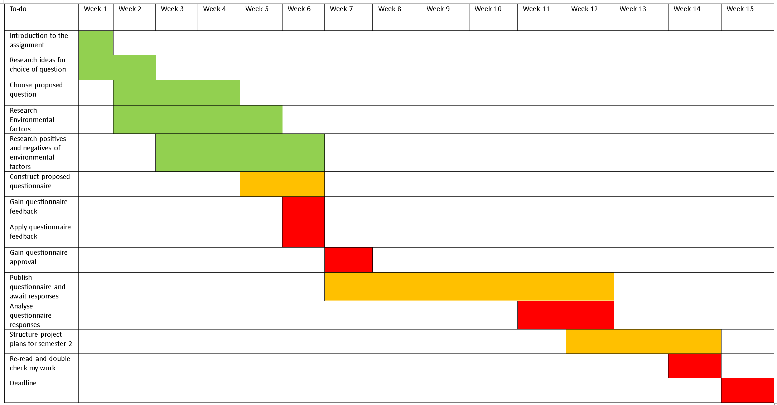

## Appendix 7: Live CV link

<https://www.alexmesnard.winchesterdigital.co.uk/?page_id=33>

## Appendix 8: Draught survey questions

* What’s your age?

18 - 24

25 - 34

35 - 44

45 - 54

55+

* On a scale of 1-10 how often do you notice environmental features used within building design?
* Do you feel environmental features such as having access to natural light provides physical and mental health benefits
* Are you aware of the term ‘Biophilic design’?
* What is your opinion on the use of Biophilic design?
* Is there any specific biophilic/environmental features you find the most appealing in building design?
* Do you think environmental design enhances the appearance of a building?

Please answer in as little or as much detail as you would like

* What are your thoughts and feelings related to this image comparison?

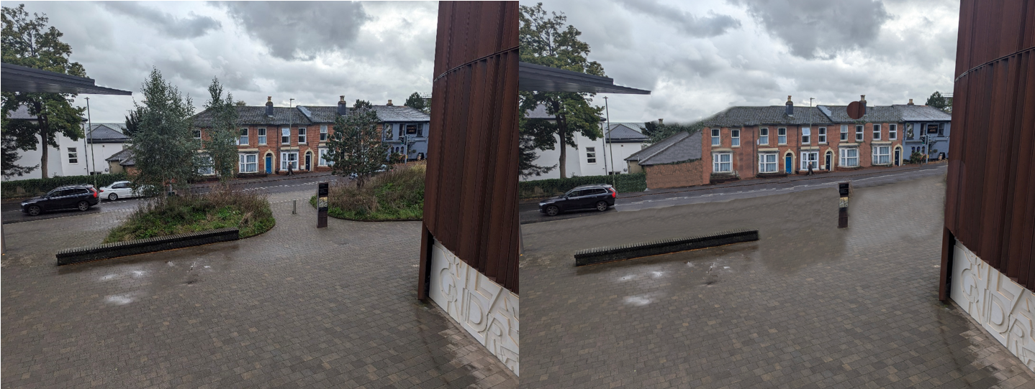

* Which of these images do you find the most appealing?

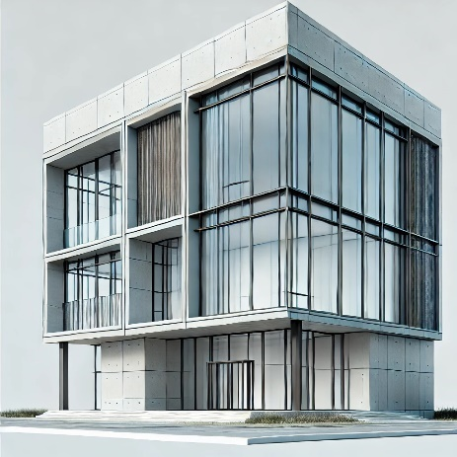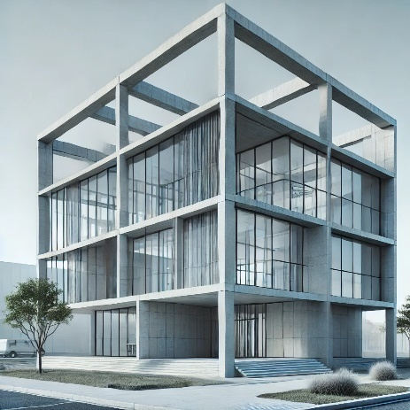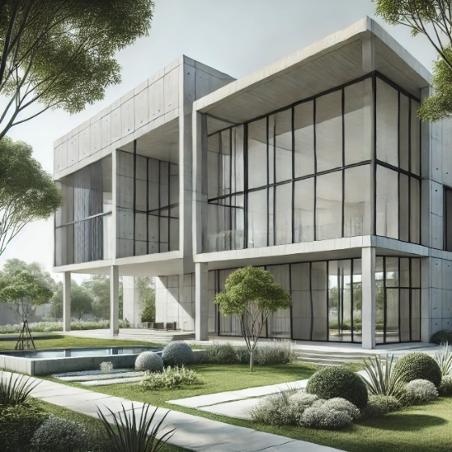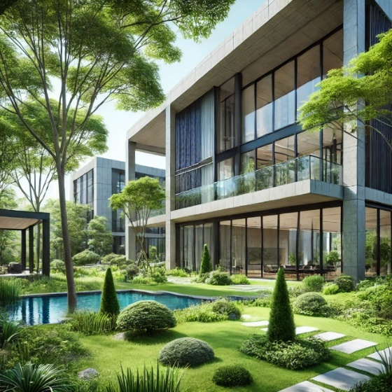

* Could you provide reasoning for your response on question 9?

## Appendix 9: Interview around proposed research questions

In order to validate my survey I decided to do an interview in order to gain an alternate perspective and receive their feedback from the questions proposed.

To do this we sat down and I gave them the draught survey questions (See Appendix 1) for them to read through, once completed they stated they had some issues with the proposed questions as they seemed to find them too difficult to answer without understanding the topic of question in more detail. This information was useful because I wanted to propose the survey to as many people as possible to get a wide range of views and increased chances of the survey being completed as the more responses given provides me with more data to analyse. The questions that posed the most issues for being too complicated were, 2, 3, 4, 5, 6, 7 .

As a result of these comments I made appropriate changes adding short sentences below briefly explaining what I am trying to ask in order to help the reader understand, additionally I decided to remove question 3 as I did not believe it to be necessary with the new written questions (See Appendix 2).

## Appendix 10: Second semester project Gantt Chart

