Negotiated design placement appendix

Appendix 1: The kitchen work triangle
Scott, D (2018) Can The Work Triangle Improve Your Kitchen Design? Danielscottkitchens. Available at: https://danielscottkitchens.co.uk/blog/can-the-work-triangle-improve-your-kitchen-design/ [Accessed 15 October 2024]
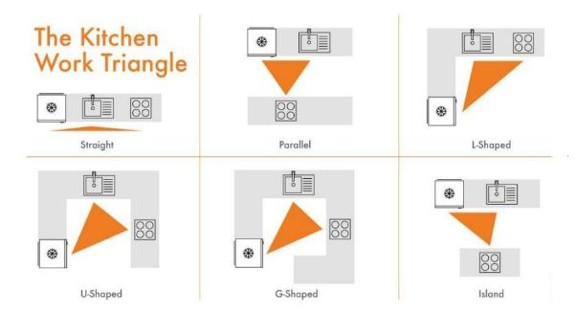

Appendix 2: SDG 12 Targets
United nations (N.D) Goal 12: Ensure sustainable consumption and production patterns. United nations sustainable development goals. Available at: https://www.un.org/sustainabledevelopment/sustainable-consumption-production/ [Accessed 20 November 2024]
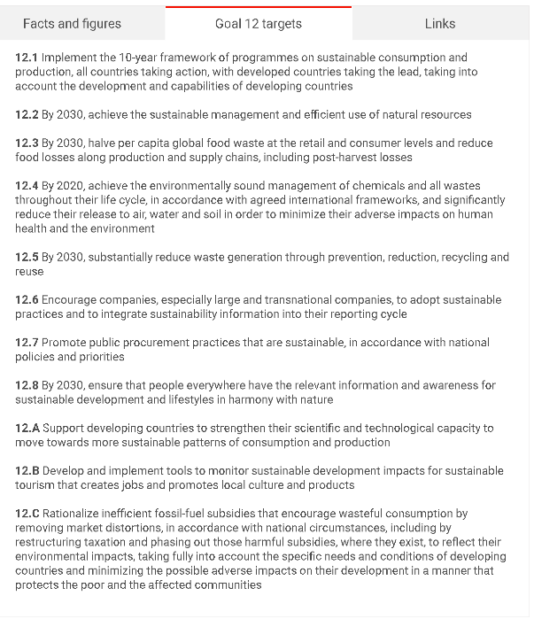

Appendix 3: How to use topography in Revit
Balkan Architect (2020) How to Model Terrain in Revit Tutorial (Site / Topography). Available at: https://www.youtube.com/watch?v=fWpgl9pJlgY [Accessed 20 October 2024]

Appendix 4: Importing Revit files into 3ds Max
Simple or Difficult (2024) How to properly export Revit file to 3ds max. Available at: https://www.youtube.com/watch?v=TDfXCOOO6yI [Accessed 20 October 2024]

Appendix 5: Learning 3ds Max
Arch Vis Artist (2022) 3ds Max Tutorial: Beginner Guide - First steps in the software. Available at: https://www.youtube.com/watch?v=BmcqcRq0Q5o&t=2s [Accessed 22 October 2024]

Appendix 6: Adding complex shapes in 3ds Max
Ativek (2017) Modeling in 3ds Max - Adding Complex Shapes to Existing Geometry. Available at: https://www.youtube.com/watch?v=oArfvJBcMhU&t=181s [Accessed 22 October 2024]

Appendix 7: Learning 3ds Max continuation
Simulation Lab (2019) 3DS MAX TUTORIAL: Beginner Crash Course. Available at: https://www.youtube.com/watch?v=YM9spHSNPpM&t=15s [Accessed 22 October 2024]

Appendix 8 : Kitchen design in 3ds Max
CCS Ltd (2024) Kitchen Design in 3ds Max | Create cabinets very easy | 3d Modeling. Available at: https://www.youtube.com/watch?v=QWcNQ5wDgqY&t=13s [Accessed 23 October 2024]

Appendix 9: Modelling Kitchens in 3ds Max
Arch Vis Champ (2020) 3ds max modeling - How to model a Kitchen in 3ds Max: the time saver technique. Available at: https://www.youtube.com/watch?v=_c4vgnezi_U [Accessed 25 October 2024]

Appendix 10: Learning how to merge in twinmotion
Architecure Vanguard (2022) How to Use the Merge Tool | Twinmotion. Available at: https://www.youtube.com/watch?v=j7Gkd5-EJA8&t=535s [Accessed 30 October 2024]

Appendix 11: Improving my day and night rendering
Twinmotion (2024) Day & night rendering: light setting best practices for stunning results | Twinmotion Tutorial. Available at: https://www.youtube.com/watch?v=g_52DTYYwd4 [Accessed 20 November 2024]

Appendix 12: Improving light in twinmotion
ViaRender (2023) Twinmotion Interior Lighting Guide for Beginners. Available at: https://www.youtube.com/watch?v=Au7ewKZeeho&t=728s [Accessed 24 November 2024]

Appendix 13: Adding grass in twinmotion
Prokarestudio (2023) HOW TO DO GRASS in Twinmotion *easy guide for beginners* 🎥💪. Available at: https://www.youtube.com/shorts/QlbWlTzdz1Q [Accessed 25 November 2024]

Appendix 14: Kitchen design considerations
Layout and Workflow
When designing a kitchen space it’s important to consider its layout as it effects workflow and as kitchens are a large part of the home and frequently used it’s important that they are practical as well as comfortable and visually appealing. One method of improving work flow and functionality is the consideration of the ‘work triangle principle’ (See appendix: 1) this is the idea that when dealing the three main work areas of the kitchen: the sink, the refrigerator and the oven they should be laid out to form a loose triangle form as this allows day to day tasks in the kitchen to be performed with ease. According to this rule, each side of the triangle should measure no less than 4ft and no more than 13ft (Doherty, R. 2022).
Due to the size of the kitchen in order to make the most use of its spaces, I believe an island would be best suited therefore it’s important to consider its use in the kitchen . As they can be used in a variety of different ways these including, storage options, surface spacing, seating and function in the work triangle.
Another point to consider is designing a space in order to avoid foot traffic, this is especially important for open-plan kitchens as you don’t want people getting in the way of the cook while cooking as it disrupts the workflow, therefore to avoid this it’s important to consider zones of the kitchen for a variety of tasks to avoid the wrong zones clashing with each other, producing distinct zones for preparing food, cooking food, cleaning and storage can help improve the work flow greatly with attention zoning social spaces in such a way that family members of guests will not have to walk through or around the cook.

Storage Solutions
In a kitchen space there are lots of items and products you must consider when producing cabinet space as too many or too little may pose storage problems, therefore it’s important to consider the types of storage options available and what some may be used for instance drawers specifically for cutlery and utensils, over the head cabinets to increase storage choices and specialised storage for items like spices or appliances. It’s important to consider the dimension to be used on these storage options especially in the case of overhead cabinets as to not allow them to be in the way or inaccessible if frequently used. As mentioned previously functionality in a kitchen is key therefore all of these considerations should be made. Luckily this project has the pantry space therefore it allows for an easy separation of products and a specific space for storage reducing the amount in the kitchen specifically allowing for the clients preference in an open kitchen design so it isn’t overwhelmed with cabinets and storage solutions.
Dimensions
In order to find a dimension standard I researched the usual dimension for kitchen cabinets, Ramsbottom kitchens (Peace, D. 2023) states the depth of kitchen cabinets is often 60cm with the width usually being a multiply of 10 or 15, therefore I chose to use the dimensions of 60cm x 60cm. Alternately for wall cabinets they tend to be 30cm deep with variable heights and for integrated kitchen appliances such as dishwashers they tend to be 60cm wide with a variety of different heights.

Ergonomics and Comfort
In order to improve the functionality and comfort within the kitchen ergonomics should be considered. These can be factors such as counter height and work spaces. In the terms of counter height typically they are around 900mm high however they can range due to the height of the client (Worktop-express, N.D). Though my client being around 5ft 8in in height allows me to use the recommended height of 900mm.
In order to design comfortable counter top spaces it’s important to consider its uses, therefore after some appropriate research I found this can include primarily food preparation and plating dinner however it should not be used in terms of storage (King, T. 2023). Therefore I have specifically allocated areas on my worktop where food preparation should be done and the area for dishing up food onto plates.

Appendix 15: File used to gain feedback
The work requested consist of updating their out of date floor plans and then produce a variety of changes to their property with appropriate visualisation to match, this work is in order to show conversions and extensions they would like to take around the property.
These changes consist of:
Upstairs
- Remove second door to the bathroom
- Convert room 1 and master into one master bedroom
- Remove over extruded wall in the master bedroom
- Leave rooms 3 and 4 intact
- Update room 2 into an office space
- Knock out riser space
- Update name for room 5 into storage/spare room
- Remove master bedroom door rather than bedroom 1
Downstairs
- Split the garage
- Wall off the garage into two half’s with a door connecting in-between
- Convert half of the garage space into a utility room
- Update previous Utility room into a pantry additionally adding a door
- Remove the door connecting the lounge and dining room
- Add an extension on the downstairs office space to match the length of the kitchen
- Expand the second lounge into a larger lounge space
- Move the toilet to the utility side of the garage
- Remove walls separating kitchen and office spaces in order to produce a large open-plan kitchen breakfast bar
- Implement a bifold door spanning across the whole wall to the garden
- Remove office side door
Before
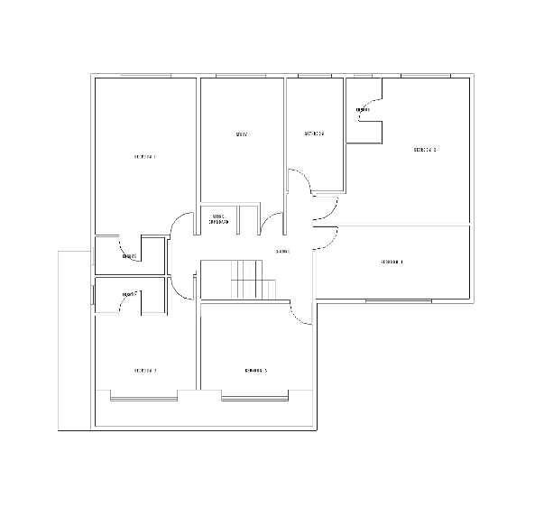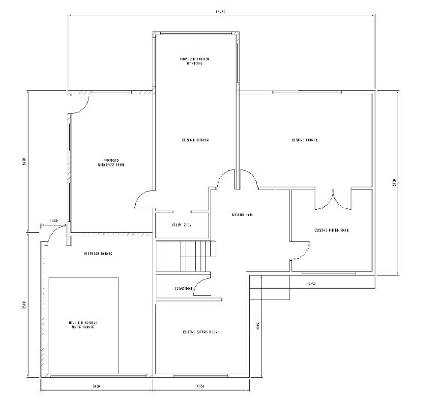
After
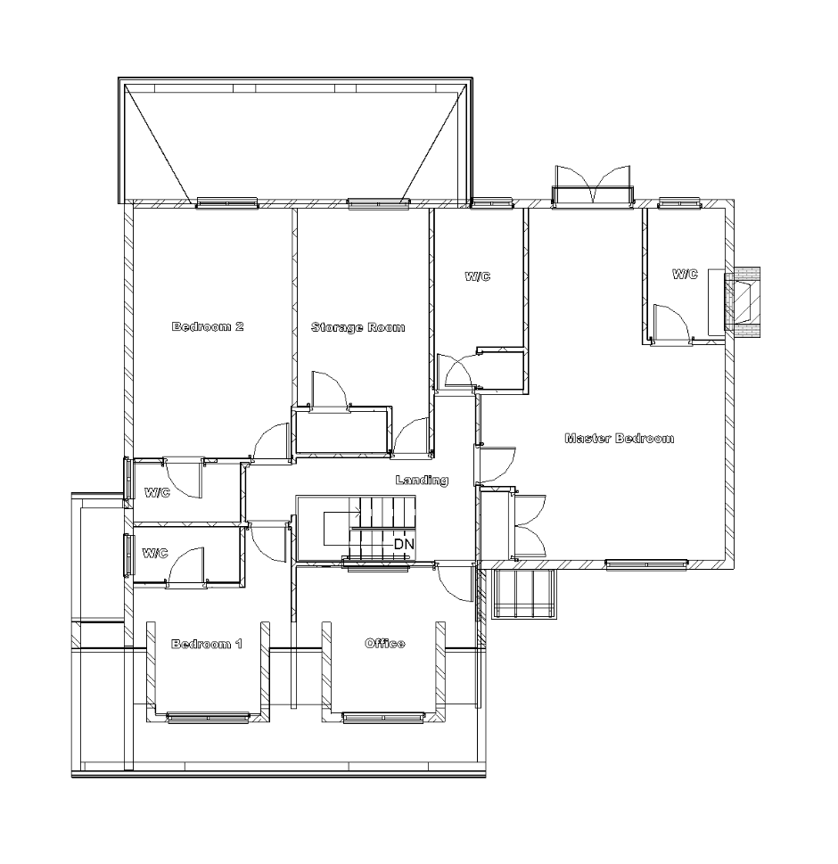
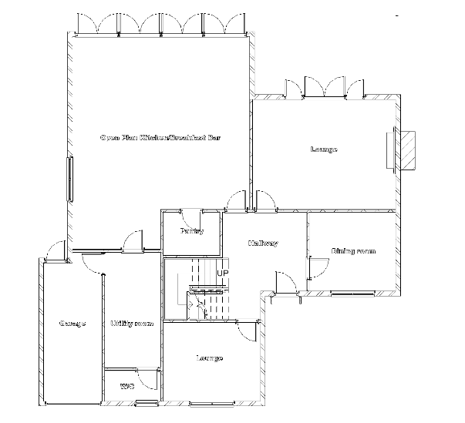

With these floor plans produced I progressed to designing the kitchen, the criteria my client give was they wanted a large open plan kitchen with a sleek modern design, a light coloured counter top and dark cabinets preferably something like grey, blue and green. Therefore I produced a range of sketched floor layouts for my client to chose from to then develop further.
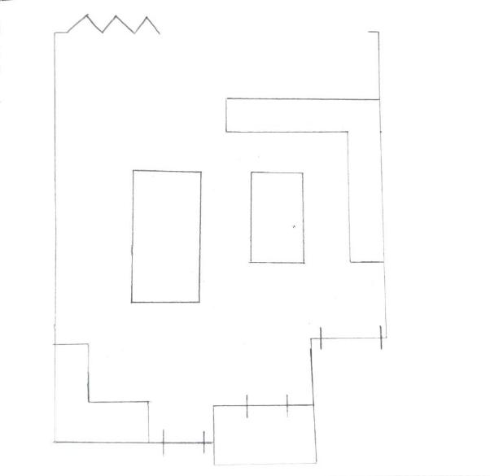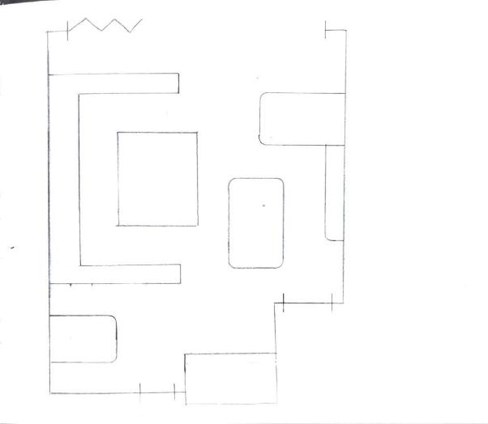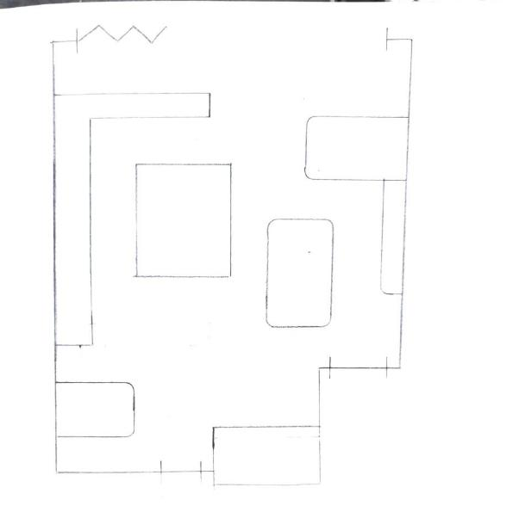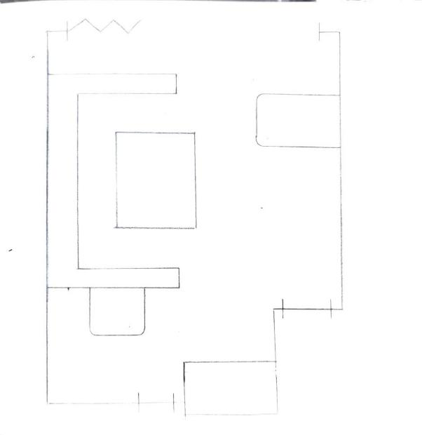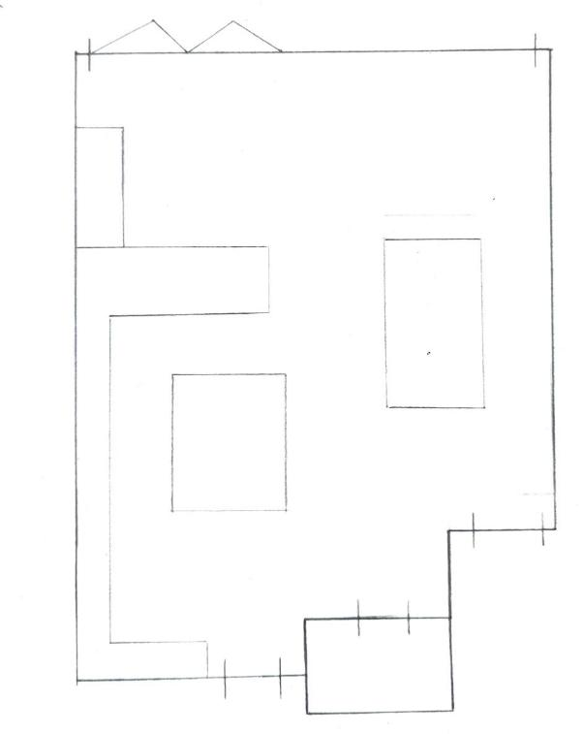
The clients preferred layout was the one selected above but proposed a few changes they would make, firstly they did not like the island in the kitchen area as it took up too much space, additionally did not like the position of the table being so far away from the bifold doors. With this information I made appropriate edits and began sketching my proposed ideas for the kitchen space as seen down below to make sure the kitchen is envisioned to how my client would like it.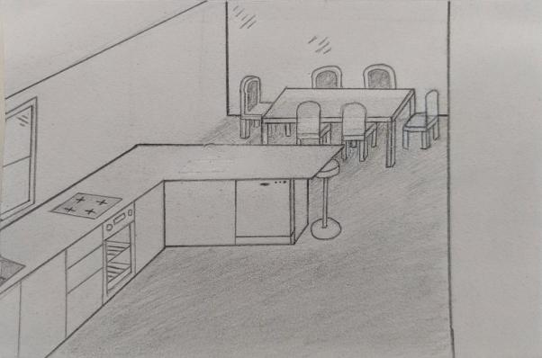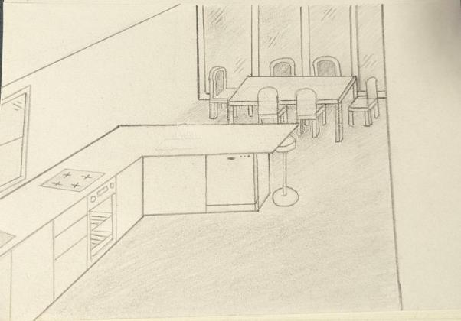

After this I began modelling the kitchen as they were happy with the layout re editing and rendering until we were both happy with the results. The few images below are some of the first iterations of the interiors layout and aesthetic as it was important to meet my clients.
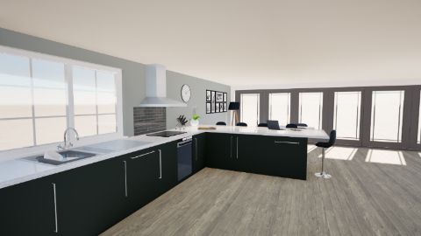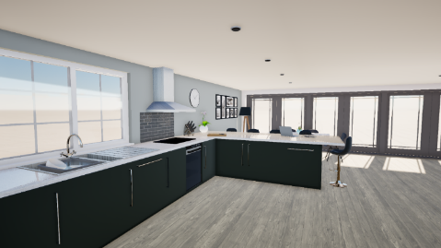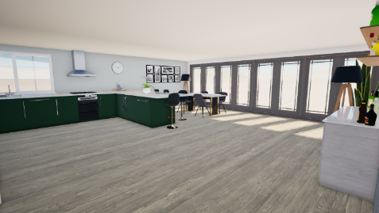

Exterior Renders
Theses renders showcase the differences with the conversion on the property with a comparison further below.
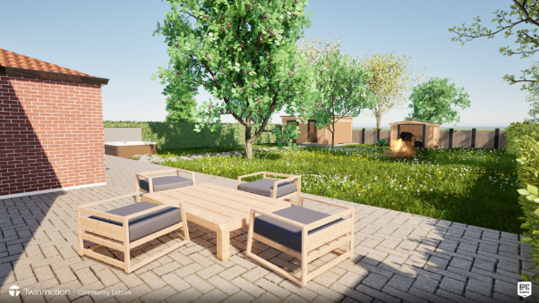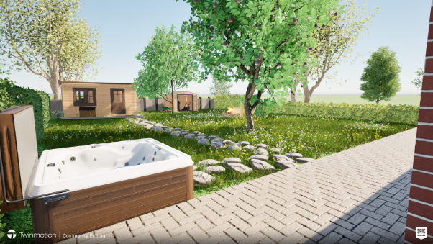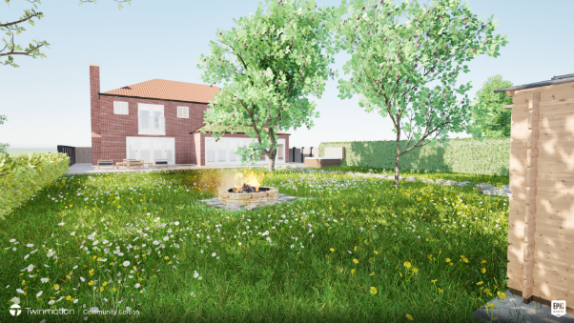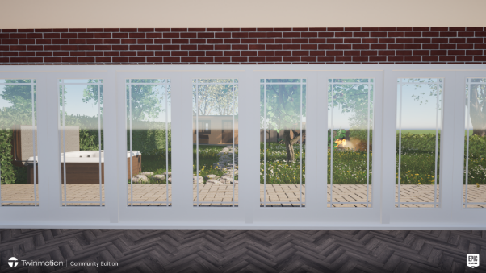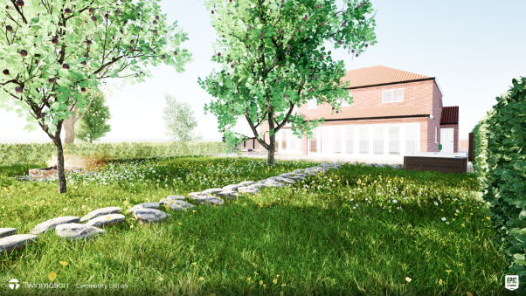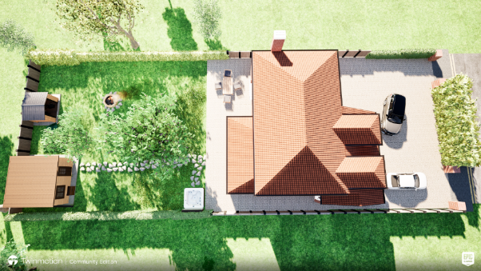
Exterior comparison renders
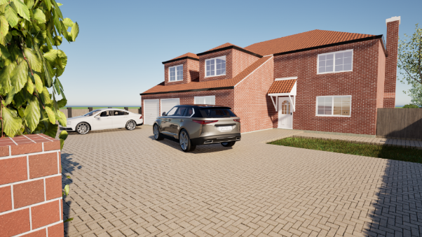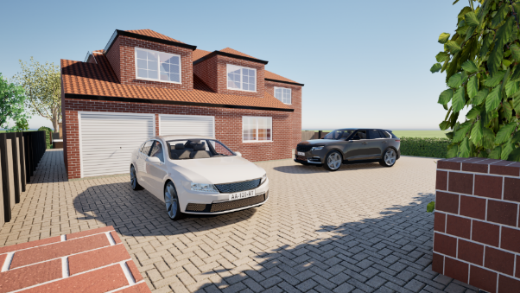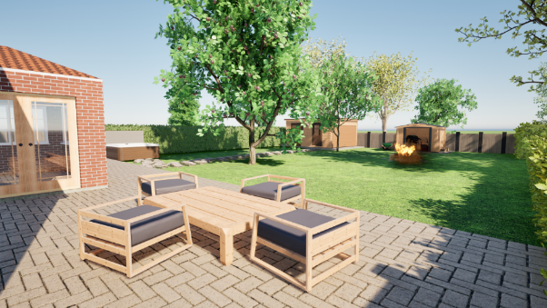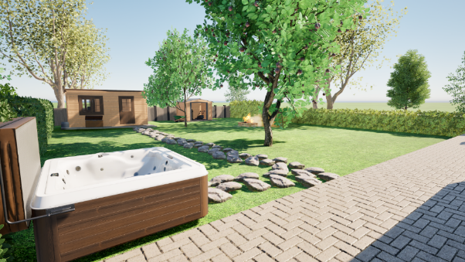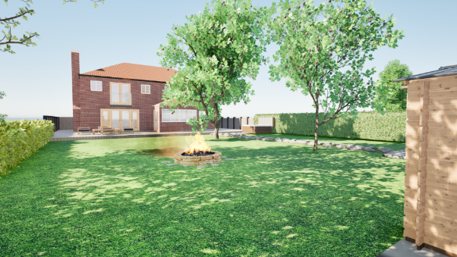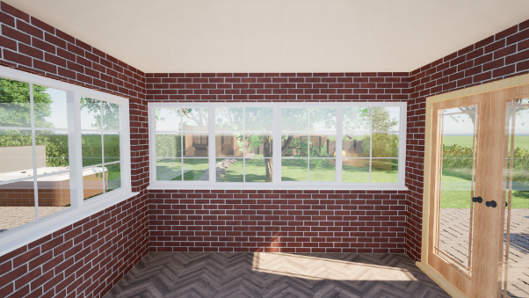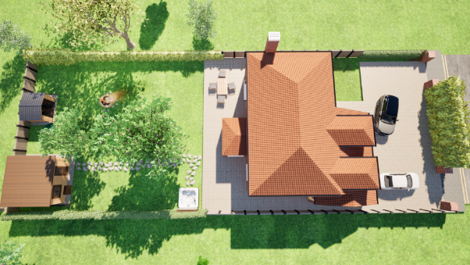

Interior Renders
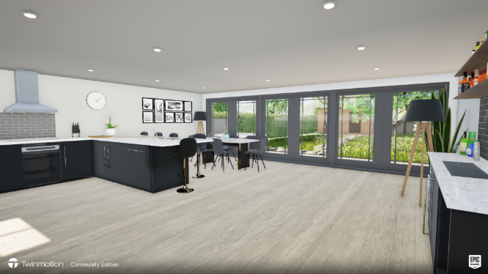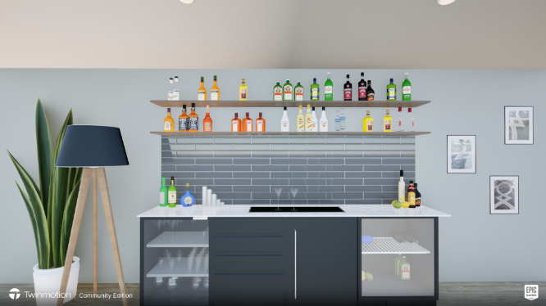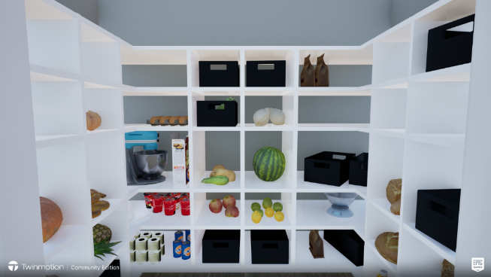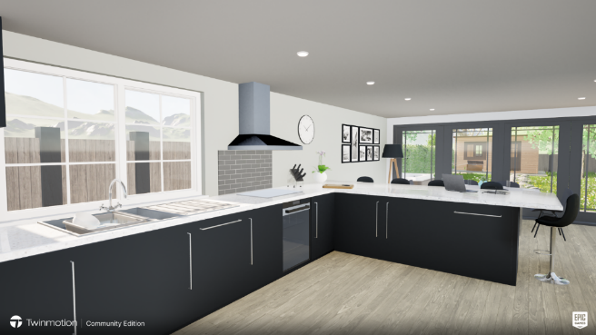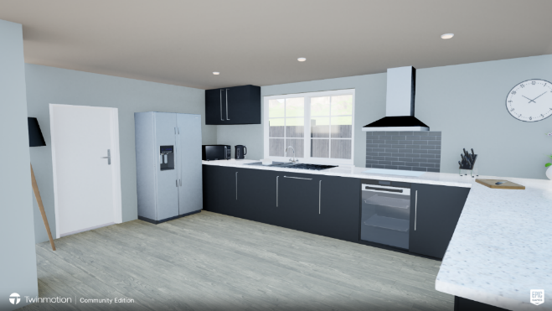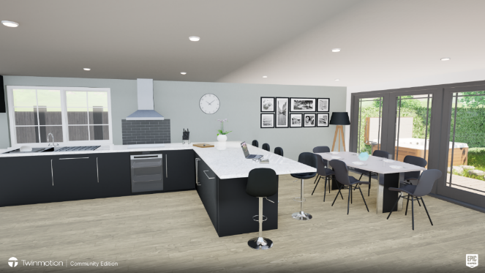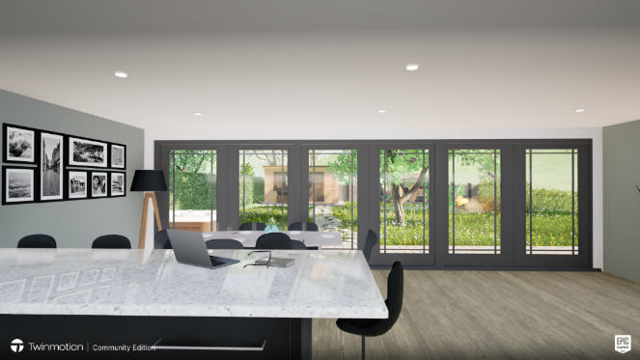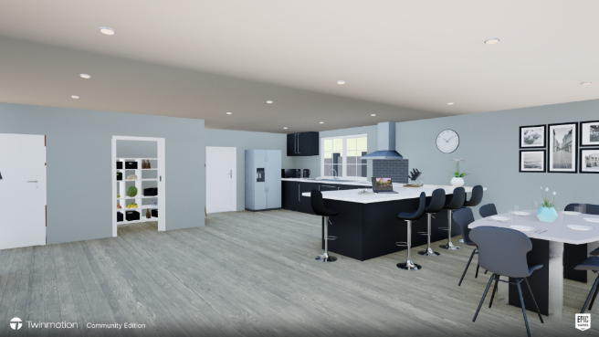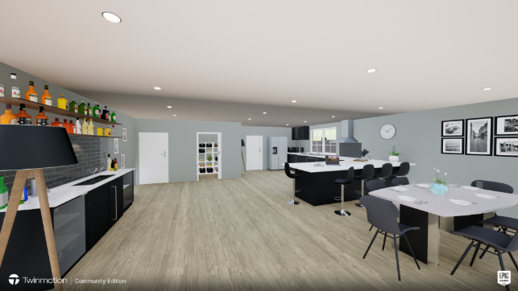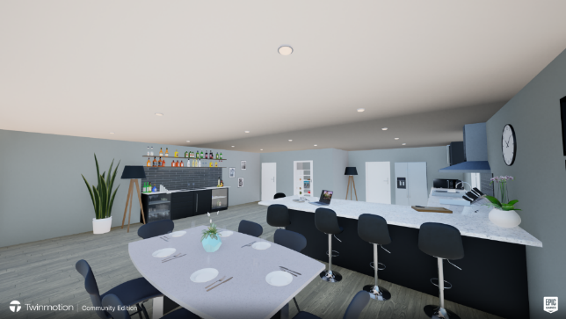

I would appreciate any feedback you can provide, whether this is positive or negative. Thank you very much for your time.
Feedback:

