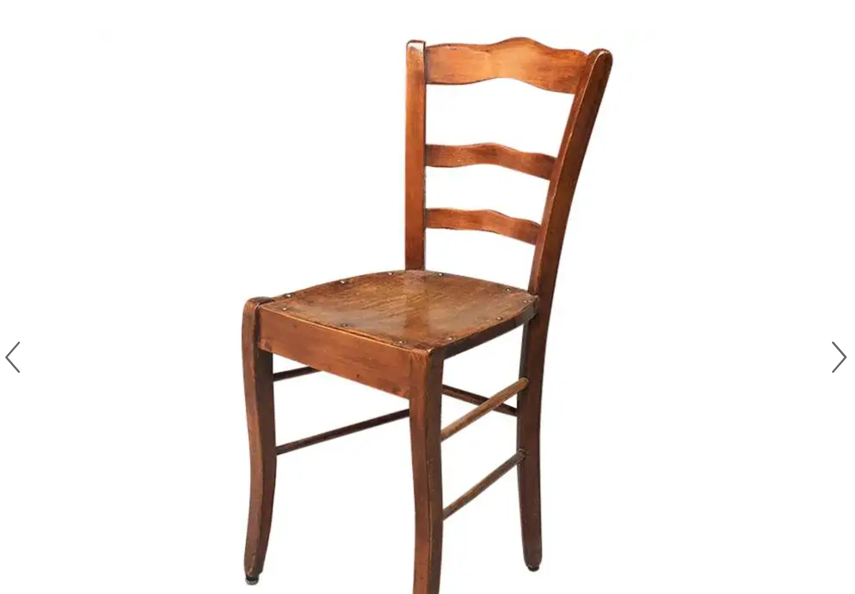
1stdibs (n.d.) Italian Early 20th Century Walnut Chair, 1900s. 1900’s Chair. Available at: https://www.1stdibs.com/furniture/seating/chairs/italian-early-20th-century-walnut-chair-1900s/id-f_22158702/ [Accessed 18 March 2024]
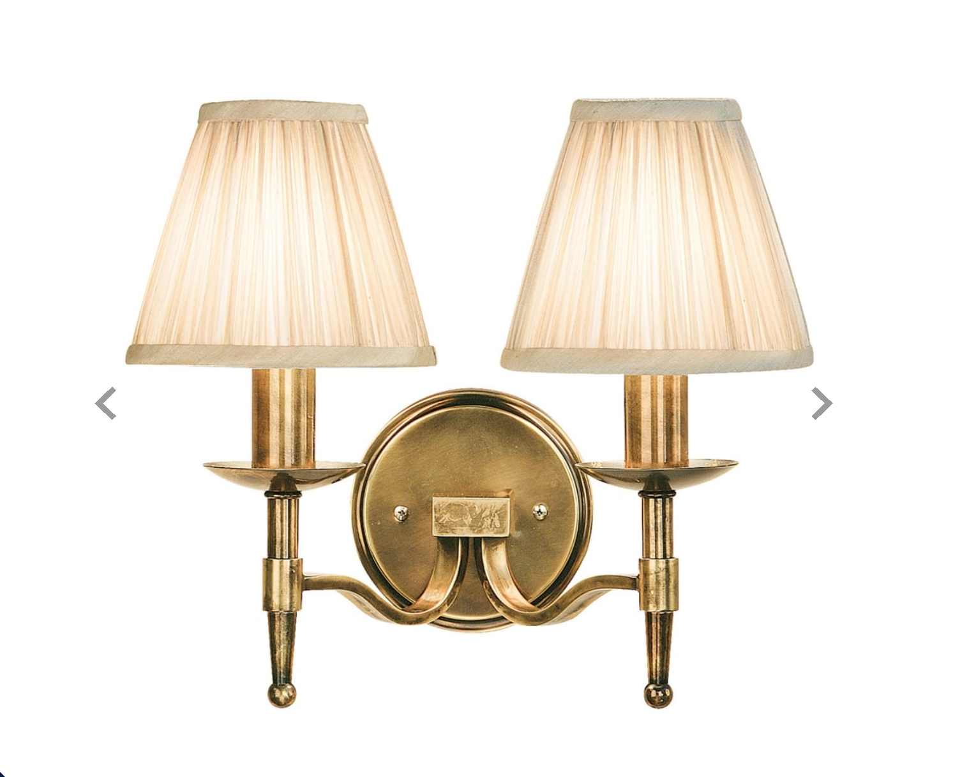Candlegatelights (n.d.) 63654 Stanford 2 Light Wall Fitting In Antique Brass Finish With Beige Pleated Shades. 1900’s wall light. Available at: https://www.castlegatelights.co.uk/interiors-1900-63654-stanford-2-light-wall-fitting-in-antique-brass-finish-with-beige-pleated-shades-p35025 [Accessed March 18 2024]
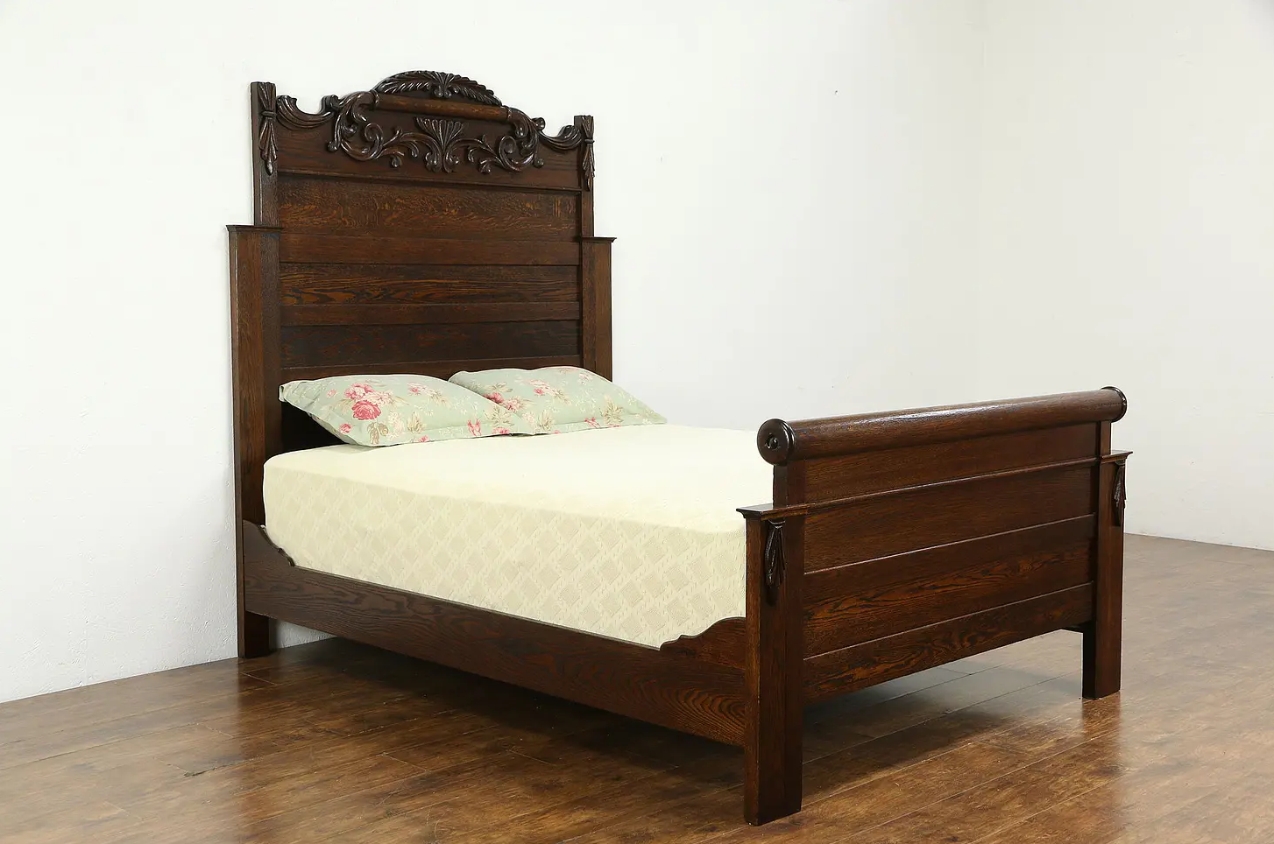Harpgallery (n.d.) Victorian Antique 1900 Carved Oak Queen Size Bed #33956. 1900’s Bed. Available at: https://www.harpgallery.com/shop/item33956.html?epik=dj0yJnU9NWRkOFNqbkJUMDV2ZVZKdXBuV1dJSXI2SmNjbU1QRzImcD0wJm49M2E1MVBFYXp3d3o4N0lZMmlIT2pMZyZ0PUFBQUFBR1pHdFhR [Accessed 20 March 2024]
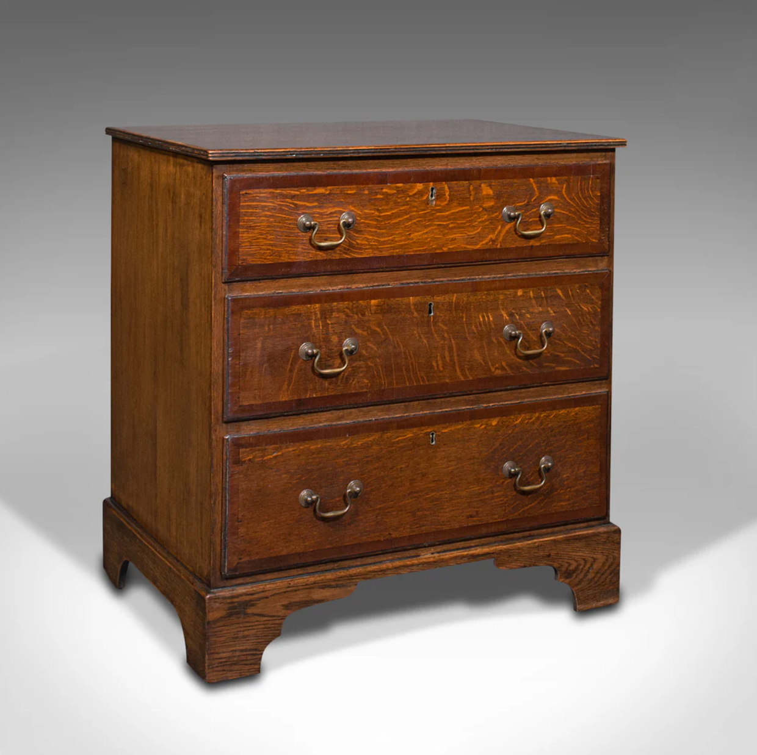Londonfine (n.d.) Antique Compact Chest Of Drawers, English, Oak, Bedside Cabinet, Georgian, 1800. 1800’s Chest of drawers. Available at: https://www.londonfine.co.uk/products/antique-compact-chest-of-drawers-english-oak-bedside-cabinet-georgian-1800 [Accessed 15 April 2024]
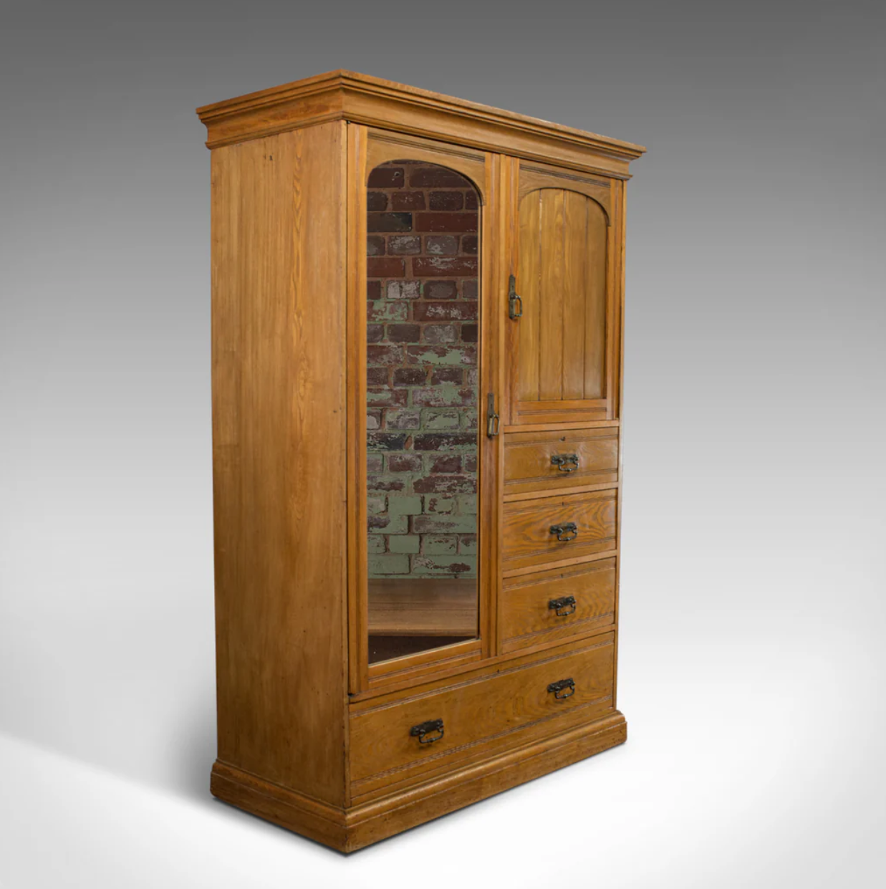Londonfine (n.d.) Antique Wardrobe, Howard and Sons, London, Oak, Linen Cupboard, Compactum C.1900. 1900’s wardrobe. Available at: https://www.londonfine.co.uk/products/antique-wardrobe-howard-and-sons-london-oak-linen-cupboard-compactum-c-1900?variant=30451468009549 [Accessed 28 March 2024]
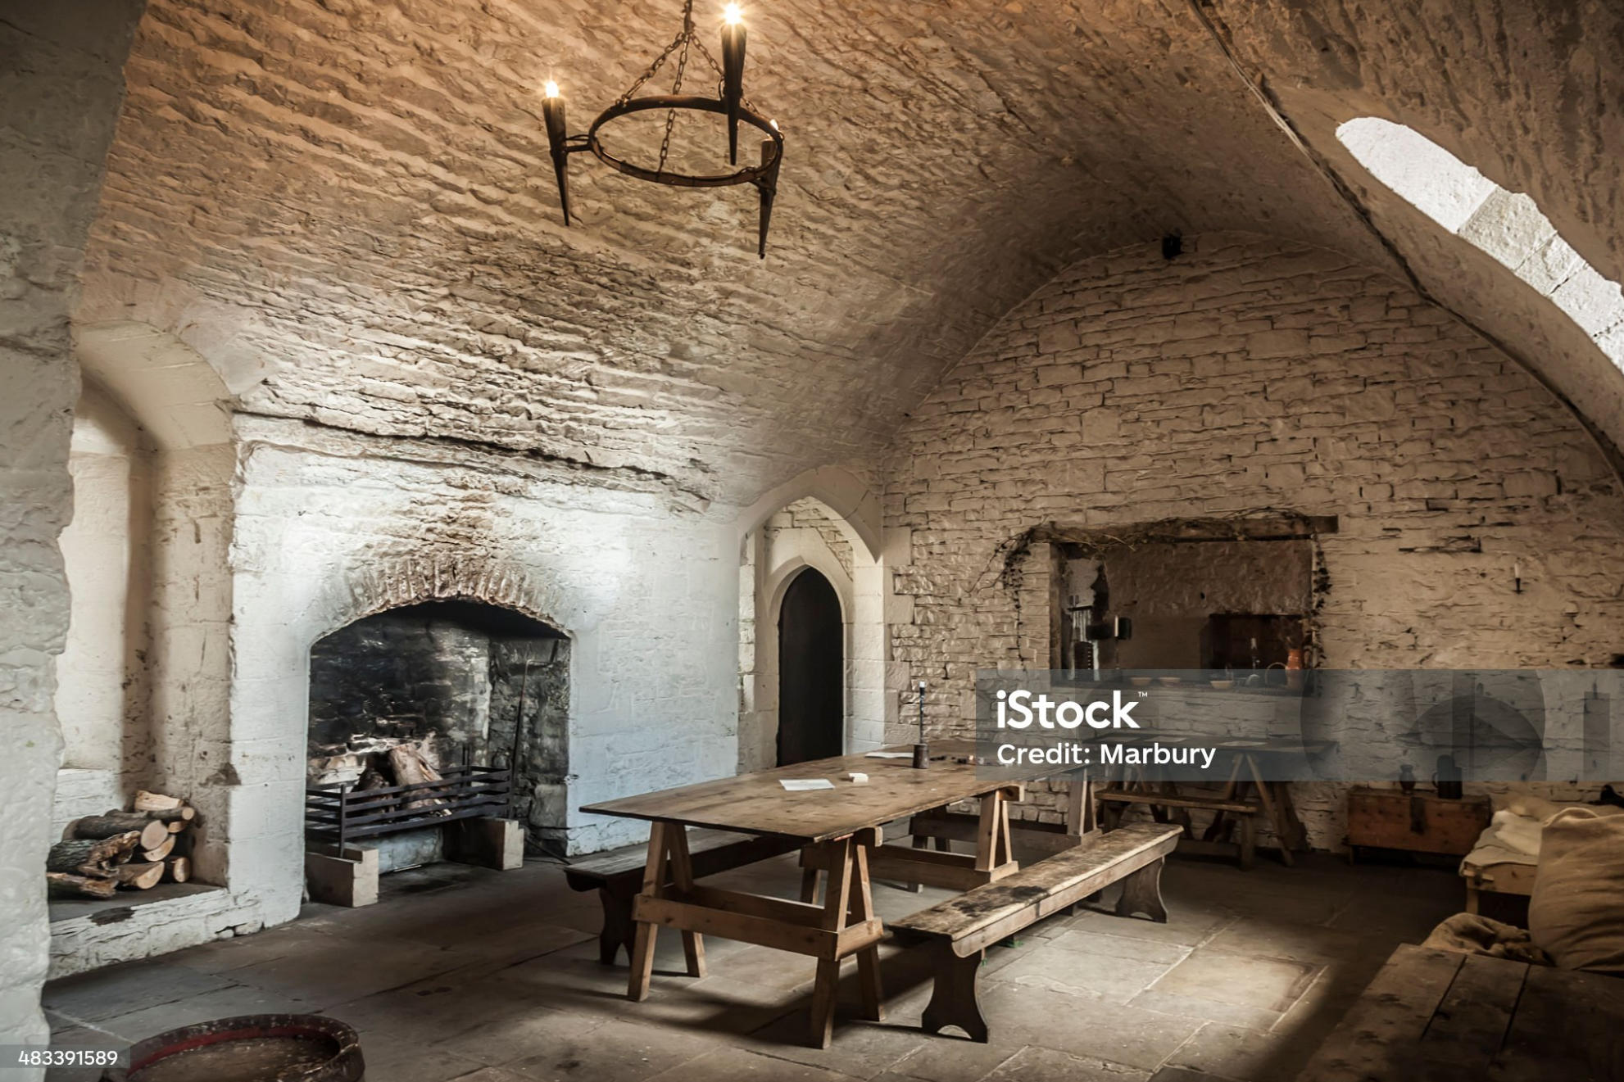Marbury (2013) Medieval Kitchen stock photo. Medieval dining room-kitchen. Available at: https://www.istockphoto.com/photo/medieval-kitchen-gm483391589-26031331?searchscope=image%2Cfilm [Accessed 28 February 2024]
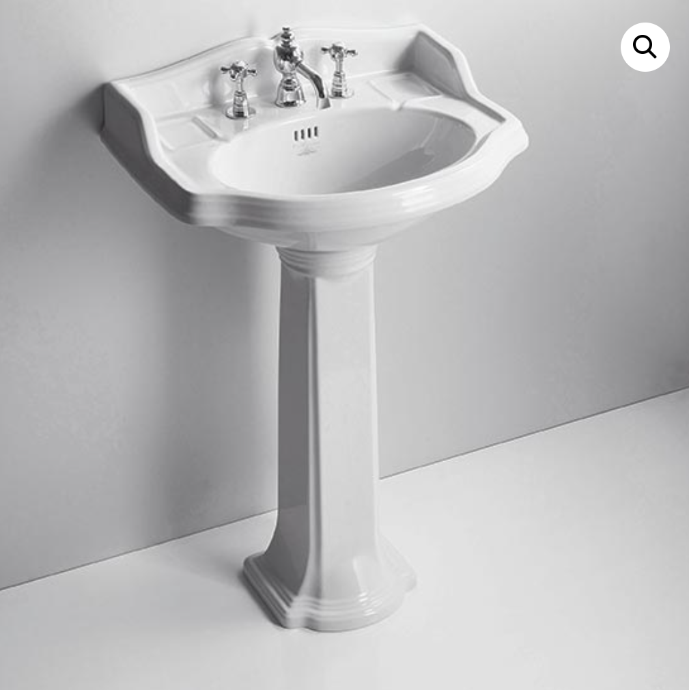Oldfashionedbathrooms (n.d.) Old England Suffolk 59cm Basin & Pedestal. 1900’s wash basin. Available at: https://www.oldfashionedbathrooms.co.uk/product/old-england-suffolk-59cm-basin-pedestal/ [Accessed 12 April 2024]
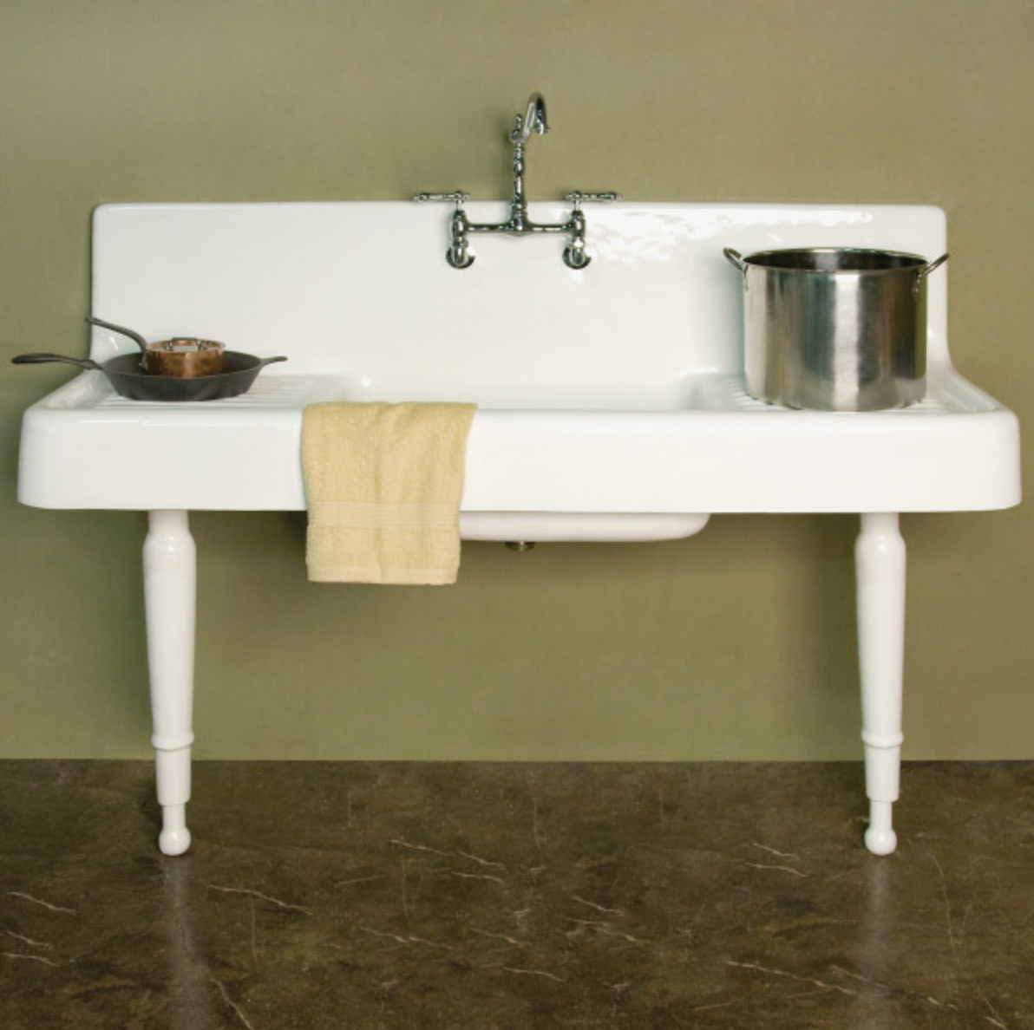Polson,M (2023) This 5′-wide drainboard sink with legs is modeled closely on a 1920s original. 1900’s Kitchen sink. Image 4:11. Available at: https://www.oldhouseonline.com/kitchens-and-baths-articles/vintage-sinks/ [Accessed 10 May 2024]
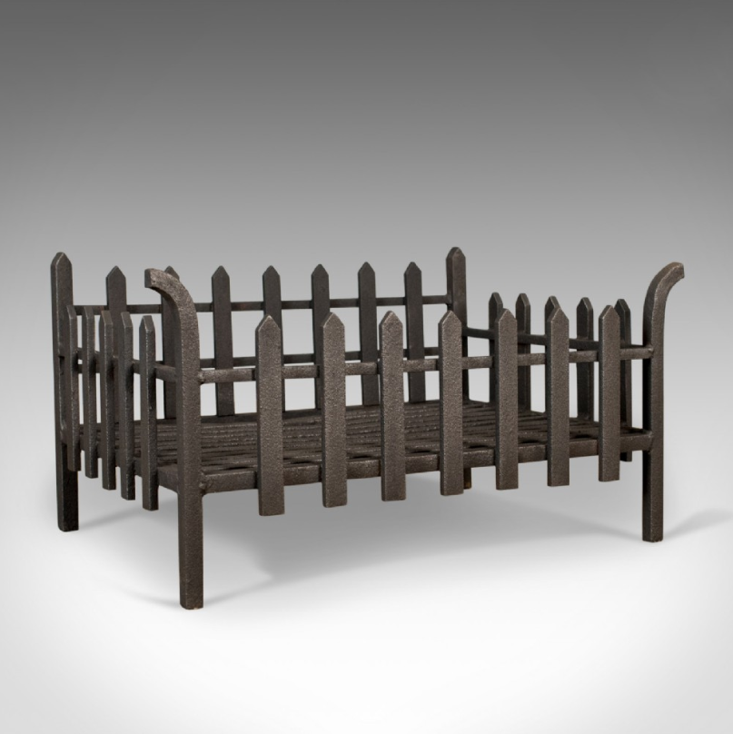Selling antiques (n.d.) Large Antique Fire Basket, English, Victorian Fireplace Iron Grate, Circa 1900. 1900’s Fire basket. Available at: https://www.sellingantiques.co.uk/543762/large-antique-fire-basket-english-victorian-fireplace-iron-grate-circa-1900 [Accessed 10 April 2024]
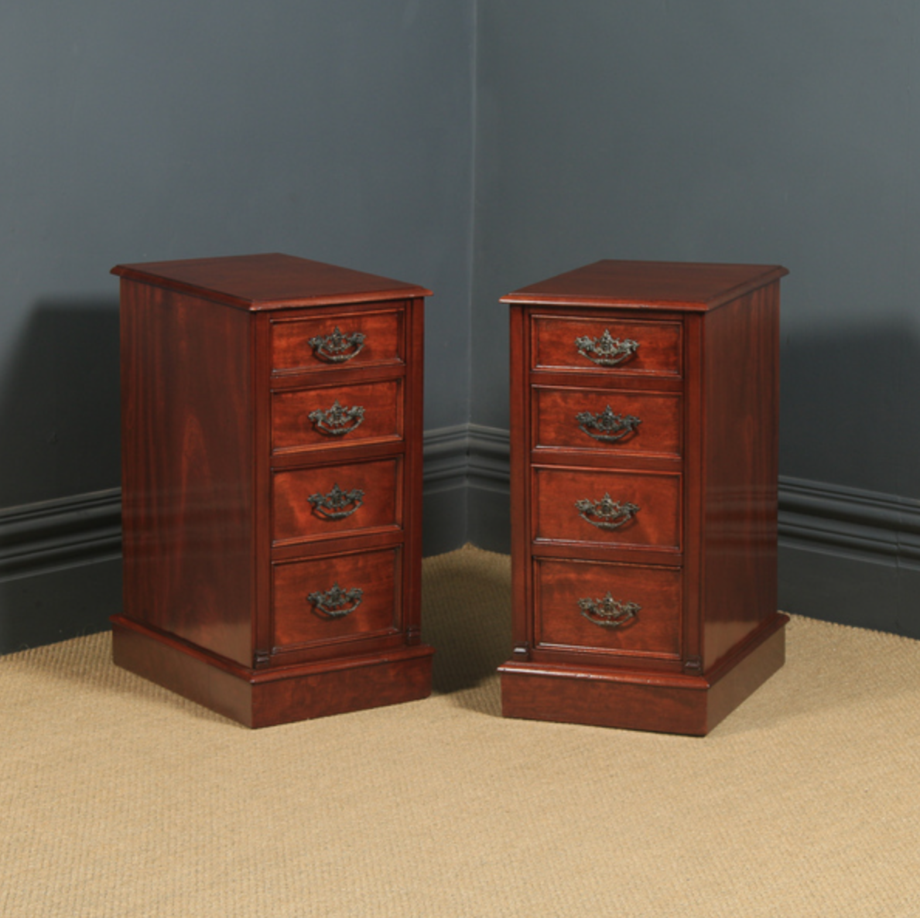Vinterior (n.d.) Antique English Pair Of Victorian Mahogany Bedside Tables Circa 1900. 1900’s Bedside tables. Available at: https://www.vinterior.co/furniture/tables/side-tables/antique-english-pair-of-victorian-mahogany-bedside-tables-circa-1900-sku96925626 [Accessed 21 March 2024]

